Estella Baby Clothes & Unique Kids Clothes, Heralds the Arrival of Kingsley & Other Designer Children’s Clothes

Released on: September 23, 2008, 5:29 am
Press Release Author: Chike Chukwulozie
Industry: Apparel & Fashion
Press Release Summary: Sales of Estella’s Kingsley and other Fall & Winter Designer Children's Clothes & Baby Clothes Help Fight Hunger in Starving Children from Over 40 Countries Worldwide
Press Release Body: New York, NY – September 22, 2008 – Estella, the leader in Baby clothes, Designer Children's Clothes & Unique Kids Clothes, today announced the arrival of designer children’s clothing including baby onesies, pants, tops, sweaters, kids coats, girls dresses, unisex baby clothes, baby boy and baby girl clothes. Collections now available include American boys clothing designer Kingsley, European children’s clothes designer Simple Kids and Hartford Kids, the children’s clothing line of French men’s and women’s wear designer Hartford.
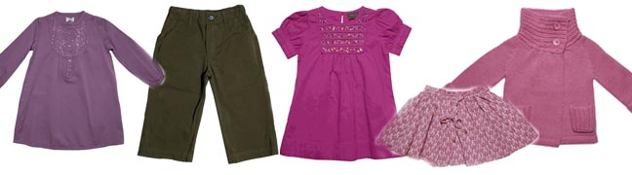
Kingsley’s Fall line is as usual unique kids clothing. Known for its graphic prints shirts, this seasons designs please not only adults, but kids too. Kingsley’s Sid Vicious t shirt for instance shows the pop idols image along with a bold print of the Union Jack. Kids appreciate the bold graphics and adults appreciate not only the graphics, but the opportunity to reminisce about the pop idol and his music. Kingsley designer children’s clothing is unique, fun and playful, not just for parents, but for the kids too.
Also unique is Hartford Kids’ Fall line. Making its debut at Estella in the spring, Hartford Kids was a huge hit and its Fall line is no different. Hartford Kids’ boys and girls’ clothes are simple, yet elegant and understated. Its boys’ polo shirts for instance have clean lines with three-quarter length sleeves, are garment dyed or possess some other detail that make them playful, wearable and fun. They use the softest cottons, wools and cashmere to assure not only that they are comfortable and warm, but also that when one kid outgrows it, you can pass it on to another.
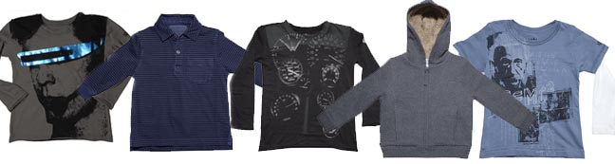
Simple Kids is another contemporary designer of heirloom children’s clothing. Designed in Belgium by British artisan Melanie Ireland, Simple Kids is not only as the name suggests, simple, but it is also sophisticated baby clothing and unique kids clothes. Simple Kids’ Norah style baby and girls’ dresses for instance are available in silk and various cotton prints. They have a ruffle bib that is pleated and some styles are decorated with sequins. These details lend these dresses to dressing up for parties with dress shoes or dressing down for the park with sneakers. Babies of course can celebrate their first holiday, birthday or any other party in these picture perfect dresses that is typical of Simple Kids.
“The arrival of Simple Kids, Kingsley and Hartford kids adds to Estella’s already rich collection of baby clothes, unique kids clothes and designer children's clothes.” saidfounder Chike Chukwulozie. “We know that luxury children clothing shoppers are looking for special items for their children and as baby gifts and kids gifts. Not only does our entire Fall collection fulfill this need, but Estella offers customers a rich selection,”added Mr. Chukwulozie.
With appearances in New York Magazine, Cookie Magazine, The New York Times, Elle Magazine, Dailycandy.com, CNN.com, Vogue, InStyle, NBC’s Today Show, Town & Country, US Weekly and numerous other publications, blogs and web sites, Estella is the leader in baby clothes and designer kids clothes. For more information on Estella or to start shopping for unique baby clothes and kids clothes, please visit http://www.estella-nyc.com.
About Estella
Renowned as the source for cutting-edge kids clothes, Estella has quietly established itself as the designer infant clothing shop that celebrities, stylists, royalty and those in the know look to when they want something fresh. Featuring distinctive and unique baby clothes and kids clothes that are brought to life with modern designs, incredible detail, unusual colors and sumptuous fabrics, Estella's innovative approach offers gorgeous items selected for beauty and character. Founded in 2002, Estella is privately held and headquartered in New York, NY. For more information about Estella, please visit the company's web site at http://www.estella-nyc.com.
Web Site: http://www.estella-nyc.com
Contact Details: 493 Sixth Avenue
New York, NY 10011
1.877.755.3553
contact@estella-nyc.com

