H Samuel launches new Giles Deacon Evoke Collection

Released on: September 30, 2008, 8:10 am
Press Release Author: H Samuel
Industry: Retail
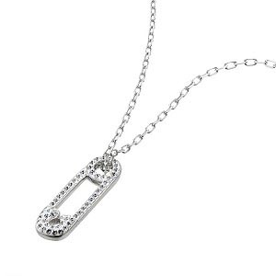
Press Release Summary: H.Samuel has launched a brand new range of Evoke jewellery designed by leading fashion designer, Giles Deacon this September
Press Release Body: H.Samuel has launched a brand new collection designed by award-winning British fashion designer Giles Deacon for the Evoke range of jewellery. This is his first ever high street jewellery collection and includes nine stunning pieces that are exclusive to H.Samuel. All of the fabulous rings, pendants and earrings in the Giles Deacon Evoke collection feature Swarovski crystals for an extra dash of glamour.
The exclusive selection includes stud earrings, pendants and bracelets with white and black crystal balls, a selection of stylish caged hearts, plus the safety pin design which includes a necklace and brooch. The collection is both fun and fashionable.
The inspiration behind the designer jewellery range encapsulates three different themes. Giles explained: "The first is based on the play of optical black and white - I love the graphic simplicity and strong impact. The second range is based on the solar planet system, small stellar constellations cluster in rings, necklaces and earrings. The third is motif based with skulls with heart-eyes, ring pulls, cherry skulls and safety pins giving an edgy, playful feel."
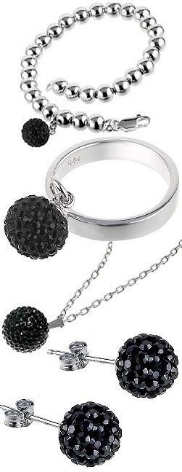
He went on to say, "Jewellery is becoming so much more important in fashion... I think the woman who will wear the collection is fashion conscious with a sense of humour and loves to accessorise her outfits".
Giles Deacon is one of the most successful and celebrated British fashion designers. He graduated fromCentral Saint Martins in London in the early 1990s, went on to design for Jean Charles De Castelbajac, Louis Vuitton and Ralph Lauren amongst others and was named British Designer of the Year 2007. His celebrity clients have included Kylie Minogue and Kate Moss.
He summed up the attitude captured in his designs,"Hopefully, if you saw someone wearing one of our frocks you'd think she looks quite interesting to have a chat with and say hello to. They're a bit 'We're on, we're out, we mean business'". The same applies to his jewellery.
About H.Samuel:
H.Samuel is the nation’s favourite High Street Jeweller with over 350 stores and a retail website atwww.hsamuel.co.uk. Featuring a stunning range of jewellery, H.Samuel also features an incredible range of branded watches (including DKNY, Fossil and Policewatches, along with collectibles and gifts for all occasions, offering something for every taste and style. H.Samuel is part of the Signet Group, the world’s largest speciality retail jeweller.
Web Site: http://www.hsamuel.co.uk
Contact Details: Tim Lundberg
Copywriter
Signet Trading ltd
E-Commerce
Imperial Place
3 Maxwell Road
Borehamwood
Herts
WD6 1JN
www.hsamuel.co.uk
www.ernestjones.co.uk
0208 207 8312

