San Francisco Bay Area vocalist LUA HADAR makes international debut with her band TWIST at the Bangkok 10th International Festival of Dance & Music


Released on: September 17, 2008, 4:57 am
Press Release Author: BZ Harrison, Bellalua Records; a division of New Performance Group
Industry: Entertainment

Press Release Summary: Following their stunning debut at New York's Iridium Jazz Club, world jazz vocalist LUA HADAR with her band, TWIST appear at the Bangkok 10th International Festival of Dance & Music, along with Zubin Mehta, Paul Taylor and the Ballet Flamenco. A unique and original vocalist with a soaring range, Hadar interprets lyrics in several languages with a charming, swinging delivery. TWIST plays its own brand of “jazz without borders,” spiced with elements of Latin, pop, funk, and international cabaret. October 6, at 7:30 PM, Thailand Cultural Center, Ratchadapisek Road, Bangkok 10320 Thailand, phone: +66 2 247 0028 www.bangkokfestivals.com. www.luahadar.com
Press Release Body: San Francisco world jazz vocalist Lua Hadar takes her sophisticated high-energy band, TWIST, on its first international jaunt appearing October 6 in theBangkok 10th International Festival of Dance and Music (www.bangkokfestivals.com). This festival comes on the heels of the successful release of her latest CD, Lua Hadar with TWIST, at New York’s famed Iridium Jazz Club. “It’s a particular thrill for me to be performing in a festival lineup that includes Zubin Mehta, Paul Taylor and the Ballet Flamenco,” says Hadar. TWIST’s tour band reflects the international flavor of Hadar’s repertoire, with musicians from Cuba, Great Britain, Hong Kong and the States, including Music Director and jazz pianist Jason Martineau and drummer Jim Zimmerman. A unique and original vocalist with a soaring range, Hadar interprets lyrics in several languages with a charming, swinging delivery. TWIST plays its own brand of “jazz without borders,” spiced with elements of Latin, pop, funk, and international cabaret. October 6, at 7:30 PM, Thailand Cultural Center, Ratchadapisek Road, Bangkok 10320 Thailand, phone: +66 2 247 0028 www.bangkokfestivals.com
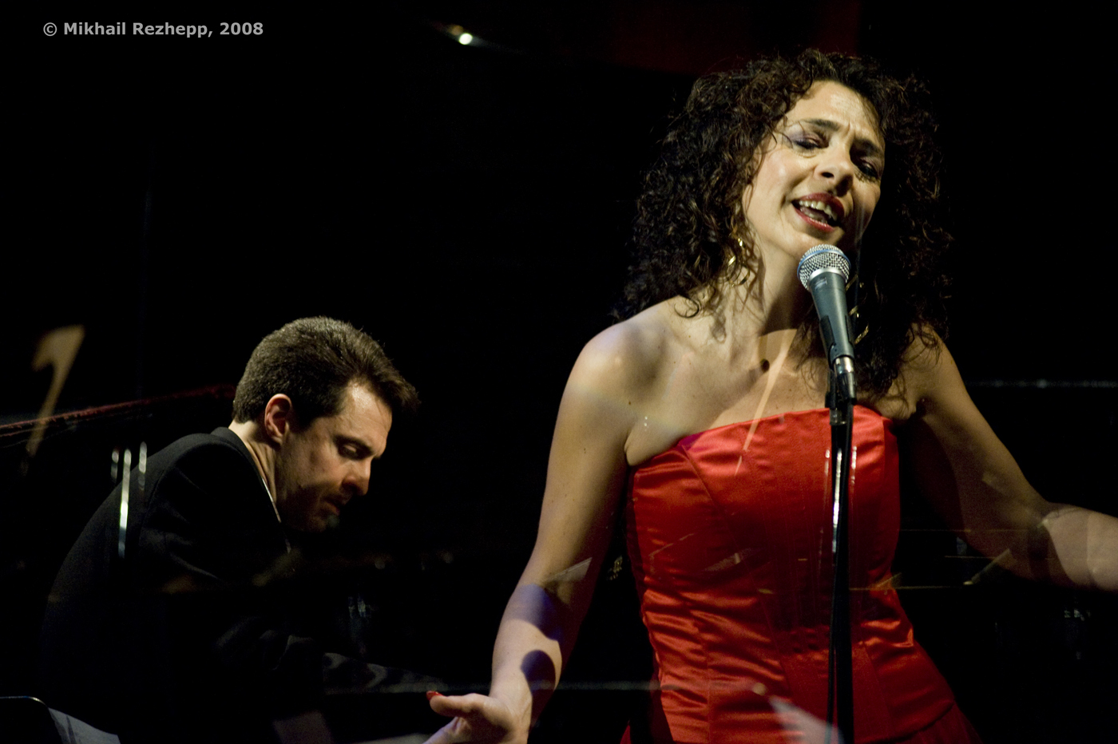
Lua moves from stage to cabaret to jazz club with effervescent ease. A native New Yorker, from a musical family, Lua Hadar has performed as an actor and singer all her life. Her love for The Great American Songbook, begun in her New York childhood, mixes with her passion for world cultures, so jazz club and concert audiences enjoy an eclectic mix of grooves and languages, from the familiar to the exotic, but always with Lua’s fresh twist.
New York critic Joe Regan Jr.wrote about the May 10th release performance at New York’s Iridium Jazz Club: - "a stunning evening - sheer beauty - every selection was dramatically on the nose - she rocked - her physical presence and body language remind one of the great Latin, Abbe Lane, at her peak. The evening was pure pleasure!"
For hi-res photos see the MEDIA page at www.luahadar.com
or contact info@luahadar.com
Photo credit: Kingmond Young
CD Cover graphics: Paige Smith
FOR CALENDAR EDITORS: SAN FRANCISCO
WHO: Lua Hadar with TWIST
WHAT: 6-piece world jazz ensemble headlined by vocalist Lua Hadar
WHEN: Monday, October 6, at 7:30 pm
WHERE: Thailand Cultural Center, Ratchadapisek Road, Bangkok 10320 Thailand
TICKETS: www.bangkokfestivals.com, phone: +66 2 247 0028
Web Site: http://www.luahadar.com
Contact Details: New Performance Group
1695 18th Street, Studio 317
San Francisco, CA 94107
For Interview/Media appearances and booking:
Contact: BZ Harrison

