Top Real Estate Expert Kenn Renner Hosts First Time Homebuyer And Tax Credit Seminars in Austin Texas

Released on: September 23, 2008, 7:23 am
Press Release Author: Buy Austin
Industry: Real Estate
Press Release Summary: Real estate expert Kenn Renner is hosting a series of timely real estate seminars and webinars free of charge designed to inform homeowners and homebuyers on how to thrive in today’s real estate and mortgage markets.
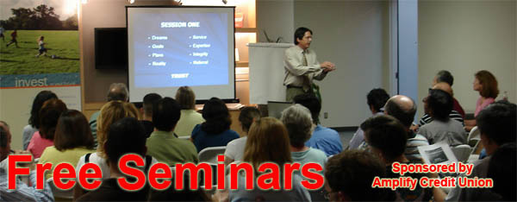
Press Release Body: September 18, 2008, Austin, TX –– Real estate expert Kenn Rennerrolls out timely seminars and webinars for homeowners and homebuyers in Austin, Texas. The educational series will cover an array of timely subjects with an emphasis on real estate. Topics include: investment, HUD foreclosures, debt cancellation, credit repair, college and retirement housing, goal setting and time management as well as property tax and income tax strategies. The seminars and webinars will be free of charge and will be held at various locations around Austin and Central Texas including colleges, universities and financial centers, including Amplify Credit Union (formerly IBM Credit Union).
One of Kenn’s timely presentations will include an in-depth study of the new legislation benefiting thousands of home seekers – “The Housing and Economic Recovery Act of 2008” and will focus on the IRS’s $7,500 first time homebuyer tax credit. This credit will allow first time homebuyers (those who have not owned a home in the past three years) to receive a $7,500 tax “credit” akin to a tax refund. Home buyers that qualify must purchase and close on a new or resale home by July 1, 2009.
To register for one of these events visit: http://www.BuyAustin.com contact Kenn Renner directly - call/text (512) 423-5626.
About Kenn Renner:
Kenn is a national speaker and author on the subject of real estate and investment. He was recently featured on national television with appearances on several episodes of the top rated HGTV show “House Hunters”. Kenn is an active real estate broker and has been consistently ranked as one of the top 5 agents of “sold homes” by the Austin Business Journal. His real estate career spans over twenty five years and in the past three years he has closed over $80,000,000 in residential transactions.
Because of the advances of video technology online, many of Kenn Renner’s seminars are offered for free on video and can be viewed on various websites including:
http://www.AustinHomeVideos.Com
http://www.FirstTimeHomeBuyerTaxCredit.tv
http://www.FederalHousingTaxCredit.tv
http://www.FreeSeminarSeries.Com
http://www.FreeWebinarSeries.Com
Press release distributed by Best Online ResultsInternet Marketing Firm (http://www.BestOnlineResults.com).
Web Site: http://www.BuyAustin.com
Contact Details: Kenn Renner
Keller Williams - Renner Realty
1927 Lohman's Crossing
Austin, TX 78734
Work: 512-218-1202
Mobile/text: 512-423-5626
Mentiona

