‘Uncle Obama’ Wants You. Namely, The Middle-Class Poor
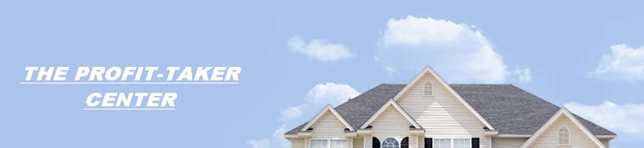
Released on: September 19, 2008, 3:19 pm
Press Release Author: Professor Don Abrams
Industry: Financial
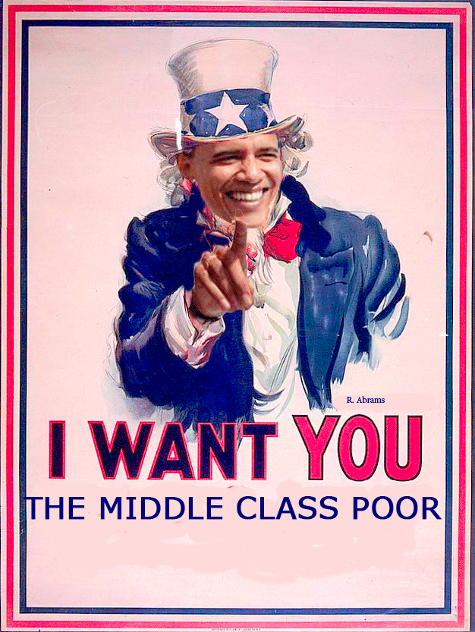
Press Release Summary: Grow with Obama from middle-class to 'zero debt' to rich in one year.
Press Release Body: Sept.19, 2008 - NEW YORK, N.Y. Have you noticed how skinny and weak the average middle-class American looks lately? Nothing but skin and bone. It’s Barack Obama, not ‘Uncle Sam’, who is saying it's time to feed the poor guy so he can do his job.
The Illinois senator plans to “relieve the burden of the middle class”. Admirable. For a start he introduces the elimination of income tax for retirees making less than $50,000 a year. For many seniors, this will eliminate the need to hire a tax preparer, resulting in even larger savings.
But he forgot a huge portion of the middle class poor. Those who make over $50,000. Those who make between $50-90 thousand per year are in the most desperate need of a tax break. They pay for all these programs that they don't qualify for. Why the $50,000 per year cap? A top-ten best-selling author of John Wiley & Sons is coming to the rescue...giving away his new book in protesting the plight of the middle-class poor.
Not only is he giving away a book, but a ‘flash of genius’ secret that enables the middle-class poor to be ‘zero debt’ and even be rich in one year. Combined with Obama’s solid start, it sounds good...which is NOT to say that it sounds too good to be true.
He is the author of the international best-seller, "The Profit-Taker: the Proven Rapid Money-Maker in Good and Bad Markets".
The Chicago Tribune says:"THE PROFIT-TAKER: SOLID ADVICE ON THE STOCK MARKET". The new free sequel reveals a proven strategy to grow rich - especially for late starters. It is a blueprint that awakens the self-actualizing quest to live long.
The author/inventor, Professor Don Abrams and legendary Professor Smarba, Professor Emeritus of Finance are protesting against those who are igniting the free fall of the middle-class poor. The culprits? Those who are fueling the fire of inflationary prices... from oil to food to books. Not to mention these scrooge-like ‘credit card interest’ plunderers who constantly pursue our unfortunate victims. This is the naked truth. But truth without action is dead.
Do Abrams and Smarba have a solution? Yes! Unequivocally.
"We don’t have turkeys to hand out, but it has to start somewhere. We recognize the debt we owe for the thunderous acclaim of the first book. To that end, we wish to set an example by being credible and responsible to our book-buying public. We have a reader friendly offer as a remedy. We wish to give back. It makes good marketing sense. It’s good for the middle-class poor and for everyone."
So for the first time ever, the revolutionary and pre-published sequel to the international best-seller is being given away. Over seven years of work in its creation. Given away. Exactly so. Free! This follow-up, "The Profit-Taker Equalizer for the Underdog: Grow from Middle-Class Poor to ‘Zero Debt’ to Rich in One Year", is yours - with love.
During these troubled times of risky ventures and banking woes, the financial duo wish to follow Obama’s lead and unleash their refreshing, uplifting and unique concept...unencumbered by any cost to the reader, without any strings attached. Simply click on www.profittaker.info and download the complete full-length manuscript copy of their ‘news breaking book’.
# # #
Web Site: http://www.profittaker.info
Contact Details: 213 Lemay St.
Cornwall, Ontario
Canada
613-932-7572
profsmarba@aol.com

