“AGING IN AMERICA”LIVE WEBCAST October 30th
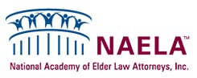

Released on: October 23, 2008, 8:57 am
Press Release Author: MINYA Concepts PR & Marketing
Industry: Law
Press Release Summary: Free Webcast with question and answer period to focus on issues of aging and how to plan for it.
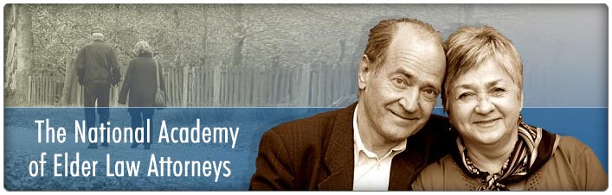
Press Release Body: Long Island, NY - October 23,2008 - AARP has joined forces withNAELA (The National Academy of Elder Law Attorneys) to present a free Webcast entitled “AGING IN AMERICA - HOW TO PLAN FOR IT.” Elder Law attorney and NAELAmember, Ronald Fatoullah has been selected as one of two elder law attorneys to host the live-streamed discussion which can be viewed at: www.naela.org on October 30, from 1-2PM, ET. All public attendance will be via the Internet.
William Stoner, AARP’s Associate State Director, will moderate the discussion, featuring insights from Ronald Fatoullah of Ronald Fatoullah & Associates, of Long Island and Queens, and Bernard A. Krooks, of Littman Krooks, on what families should do now to prepare for the future. During the program, attendees will have the opportunity to ask questions.
From living quarters to living wills, the three experts will help educate the audience on available options related to senior housing and medical decisions. Other topics might include maintaining a financial legacy for children, and how to talk with aging parents about long-term care options, and key documents to have in place for proper health-care decision making.
To attend the Webinar, visit www.naela.org and click on the “AGING IN AMERICA” webcast registration button. You may also call the offices of Ronald Fatoullah & Associates for further information at 1-877 ELDERLAW. There is no charge to attend but registration is limited.
######
Web Site: http://www.NAELA.org
Contact Details: Ronald Fatoullah & Associates, Long Island and New York
1.877.ELDERLAW

