Elemis Reveals its Christmas Collection

Released on: October 17, 2008, 5:48 am
Press Release Author: Elemis
Industry: Retail
Press Release Summary: Elemis has unveiled the gifts that will make up their Christmas collection.
Press Release Body: Elemis, the leading luxury British spa and skincare brand, has revealed the products that will make up their 2008 Christmas collection.
The Elemis Christmas collection will contain a number of limited edition gift sets with savings of up to 59% on some collections, all of which are designed to offer the best in skincare and body care.
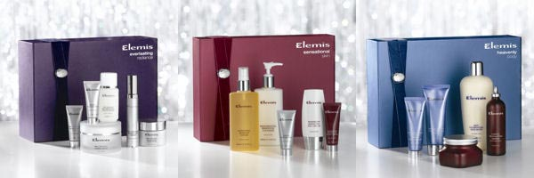
Gift sets include the Everlasting Radiance collection, featuring clinically proven anti-ageing products, the Heavenly Body gift set which contains award winning body careproducts, Exotics and the new anti-ageing Pro-Collagen range.
The Elemis formulations used in the new Christmas collection are designed to dynamically treat the skin with powerful results. Elemis sources natural ingredients and Actives from around the world and uses formulation technology to create dynamic skincare and body care products.
The Sensational Skin collection features day and night skin creams, Soothing Apricot Toner and Papaya Enzyme Peel to leave the customer with glowing and radiant skin. TheRevealing Beauty collection also offers a patent-pending resurfacing system to combat the effects of ageing and minor skin imperfections.
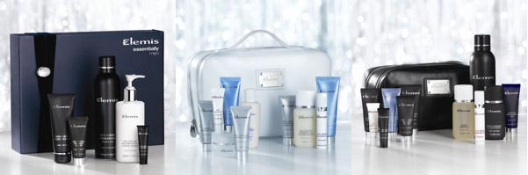
Elemis have also launched skincare and body care sets designed specifically for travellers. The Dream Journey Traveller collection for her features ten Elemis products, presented in a travel bag. For men, there is the Universal Traveller collection, featuring a variety of grooming products, also contained in a smart travel bag.
Also for men, Elemis have created the Essentially Men collection including a three phase grooming programme that features Ice-Cool Foaming Shave Gel, Tri-Enzyme Resurfacing Facial Wash and Energizing Skin Scrub along with an anti-ageing moisturiser and eye cream.
Elemis has also unveiled the Spa Candle Collection, featuring a wide range of naturally scented candles offering different fragrances to help shoppers feel relaxed, revitalised or uplifted
About Elemis:
Elemis (commonly referred to as Time2Spa) is part of the Elemis group, the pioneering British spa and skin care brand. Elemis is proud to partner with over 1200 luxurious spas and salons, 130 lavish cruise ship spas, British Airways Elemis travel spas and over 100 retail stores around the globe. Elemis treats over 5.7 million people each year and has the single largest influence on trends and developments in the global spa and skincare industry. The successful combination of powerful natural ingredients, cutting-edge formulation technology and proven clinical trials has enabled Elemis to bring to market some of the most influential anti-ageing homecare products and professional spa-therapies the beauty industry has ever seen.
Web Site: http://www.timetospa.co.uk
Contact Details: Emily Buchanan
10 Haunch of Venison Yard
Mayfair
London
W1K 5EX
020 7907 2743

