Littlewoods Direct Relaunch Ravel Footwear Collection for Autumn Winter 2008


Released on: October 10, 2008, 11:30 am
Press Release Author: Littlewoods
Industry: Apparel & Fashion
Press Release Summary: Littlewoods Direct is re-launching the Ravel footwear collection just in time for the 2008 autumn and winter seasons
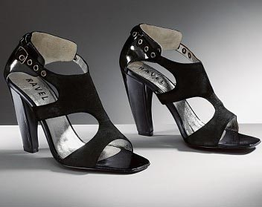
Press Release Body: Littlewoods Direct, the UK's leading online and home shopping retailer, has announced the re-launch of theRavel footwear collection, offering a number of a variety of in-vogue styles, which will appeal to fashion minded women looking to wear the finest winter fashion trends.
The new collection captures a multitude of looks, from stylish workwear through to party styles, all of which encompass Ravel’s own unique characteristics.
Heels in all shapes and sizes have been combined with an eclectic variety of finishing touches to give the range a real point of difference. Heels, stilettos, the ultra modern cone heel and the platform have been incorporated onto an array of styles. Detailing, such as including striking patent and suede combinations, snake skin effect applications, buckle features, covered buttons and pepper pot punching have also been incorporated into the collection.
Applying subtle twists to the Mary Jane style, Ravel offers a new interpretation to this look for the season. Almond points have been teamed with an assortment of detailing which includes brogue cut out trims, contrasting wooden stack heels and feminine fastening systems which all provide this styling with a fresh new look. Also featuring strongly in the shoe range are a number of T-bar designs, which are available across a spectrum of styles from striking daywear through to alluring sandals for the party season.
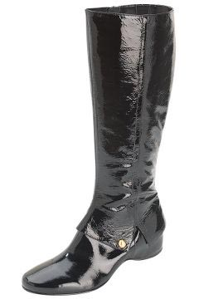
Suede shoe-boots, patent knee highs and casual options with blunted toes are featured within in the boot range.Womens fashion devotees will appreciate the finishing touches that have been applied such as contrast stitching, overlay detailing, buckle features and brogue inspired touches which all add to the modernistic look of the collection.
The attention to detail which is lavished on every pair ofRavel womens shoes and boots ensures that the wearer creates the ultimate head turning statement. Plush suede and soft leather uppers are teamed with a rich colour palette of ruby reds, rich teal, moss green, luxurious mink and deep purple, together with strong metallics.
-ends-
About Littlewoods Direct:
Littlewoods Direct is part of the Shop Direct Group, the UK's leading online and home shopping retailer, offering homeware, men's and womens clothing, toys, gifts and jewellery, electricals and appliances, furniture and sports equipment.
Web Site: http://www.littlewoods.com/
Contact Details: For further press information, please contact:
Ruth Szyszkowski
Lee Publicity Public Relations
LWD Head of Public Relations
88 Islington High Street
Angel
London
N1 8EG
020 7359 2288

