Maternity Christmas Shopping


Released on: October 21, 2008, 7:25 am
Press Release Author: Fertile Mind
Industry: Apparel & Fashion
Press Release Summary: As the warm weather of summer comes to it’s time to start looking for the maternity clothes that you can wear to those Christmas and end of year parties.
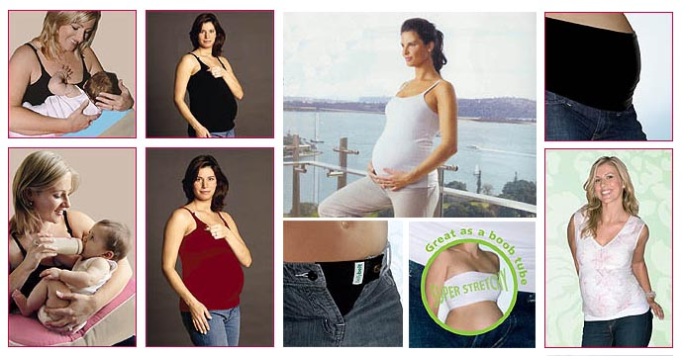
Press Release Body: Fertile Mind have a great solution with their Glamourmom Transaction Tank that comes in a beautiful Ruby Red and is not just for maternity by also contains a built in Nursing Bra that will allow you to feel cool and comfortable while feeding your baby in the new year.
A complementing product is the Milkbar Portable Nursing Pillow that you can take anywhere with you so that baby is always positioned for comfortable feeding. This clever invention saves your shoulders by elevating baby to the breast rather than you having to hold them up to this height.
If you are looking for a little something for a friend who is pregnant over Christmas, Bando is a great little gift because of it’s versatility and comfort. Not just a t-shirt extender but it can also be used as a boob tube under strapless garments for additional support.
Web Site: http://www.fertilemind.com.au/maternity-wear
Contact Details: Fertile Mind Pty Ltd
PO Box 215
Seaforth NSW 2092
Phone: +61 2 9905 0199
Fax: +61 2 9905 0322
www.fertilemind.com.au
sales@fertilemind.com.au

