Select Property launches Aquitainia luxury development
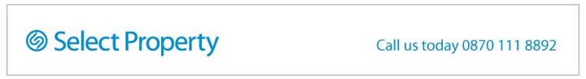
Released on: October 2, 2008, 6:09 am
Press Release Author: Select Property
Industry: Real Estate
Press Release Summary: Select Property has announced the launch of a new exclusive luxury development, called Aquitainia, which will be located on the famous The World development in Dubai
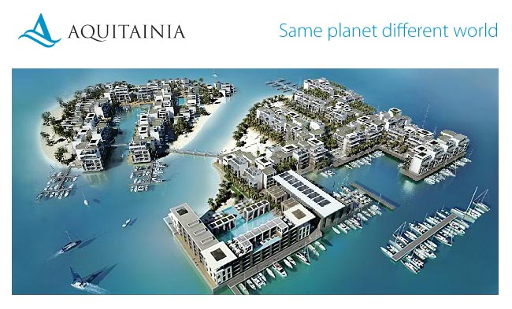
Press Release Body: Select Property, UK property developer, and Dubai based Select Group have teamed up to launch the exclusive luxury development; Aquitainia, which is located in Dubai on the fabulous 'The World' development.
Located just four kilometres off the coast of Dubai, the project is scheduled to be completed in 2012.
The new Aquitainia property development is situated on the fusion of the two islands, France and Spain, which form part of the awe-inspiring archipelago cluster of 300 islands which create 'The World'.
Designed to compliment the artistic creation of The World, the £750million development combines the Mediterranean elegance and minimalism of modern contemporary living. Set within a truly sensational setting, Aquitainia consists of 816 properties spanning over 1 million square feet. The properties will comprise of one and two bedroom suites, three bedroom penthouses, as well as beach and water villas. Each unit will include state of the art equipment and the villas will have stylish rooftop plunge pools with spectacular views across the Indian Ocean.
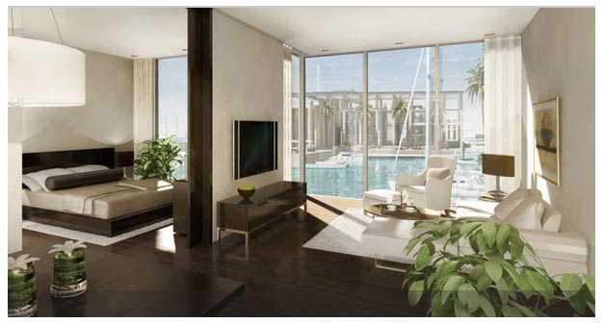
Aquitainia is centrally located amongst the islands and is close to the four main transportation and commercial hubs, offering easy access to Dubai's white washed shores. Sailing enthusiasts will also able to accommodate their yachts in Aquitainia's marinas which will have ample berths for hundreds of boats. The marinas will offer residents a variety of amenities such as cafes, restaurants and shops or simply a place to absorb the fun and sporting atmosphere.
Properties on Aquitainia will use the names of some of the most popular regions in both France and Spain to compliment the islands themselves. Monaco, Cannes and St Tropez will be used to represent France, whilst Marbella, Barcelona and Madrid will represent that of Spain.
Residences are already being made available for private purchase with a choice of one-bedroom suites starting from £498,000. Dubai's thriving population and increasing popularity ensures great investment potential whilst providing an ideal tax free lifestyle.
About Select Property
Operating since 2004 Select Property has become a leading specialist in off-plan overseas investment property. Following initial success marketing and selling luxury residential property, on an exclusive agreement basis, in March 2008 Select Property took the landmark decision to move into development, launching Pacific the first of two residential projects located on Al Marjan Island, in the emerging emirate Ras Al Khaimah, United Arab Emirates. Pacific is a joint development with Select Group
The company currently has 90 employees operating out of offices in the UK and Dubai. By May 2008 Select Property had successfully sold over £550million worth of property to customers in 53 countries.
Select Property and Select Group have enjoyed a successful working relationship since 2004, with Select Property exclusively marketing and selling Select Group's off-plan Properties in Dubai.
Web Site: http://www.selectproperty.com
Contact Details:
Media Contact:
Kate Matheou
IMD PR
Unit 4C
Bannon Court
54 Michael Road
London
SW6 2EF
+ 44 20 7371 0995

