Surgicare unveil new Cosmetic Treatment
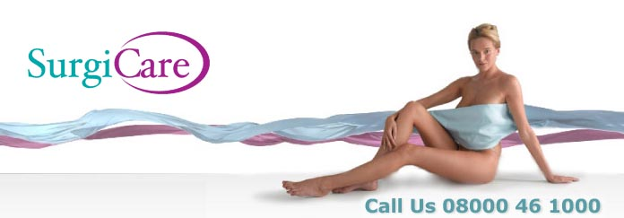
Released on: October 10, 2008, 11:09 am
Press Release Author: Helen Conyers
Industry: Healthcare
Press Release Summary: Surgicare has added a chest rejuvenation procedure to their portfolio of treatments.
Press Release Body: SurgiCare, one of the UK’s leading cosmetic procedure providers, has added chest rejuvenation to its portfolio of treatments, following large demand for the procedure across the US.
Chest rejuvenation uses Botox to correct the tell tale signs of sun damage and wrinkly skin on the décolletage and has proved to be a popular new breast treatment in the US, with many predicting a similar response upon the introduction of the procedure in the UK. However, Surgicare are taking the treatment a step further, using filler technology rather than Botox for its procedures.
Using advanced Restylane Vital technology SurgiCare is able to combat the signs of ageing and sun damage for its patients by injecting the clear hyaluronic acid (HA) gel into the skin to replenish the skin's own HA levels, adding volume, hydrating the skin, and softening lines and wrinkles.
Restylane Vital is a new development in skin rejuvenation, providing deep hydration and moisturisation from within to improve skin tone and health. It stimulates the production of collagen and elastin to keep skin looking plump and hydrated, diminishing the appearance of fine crêpey lines caused by sun damage.
Mark Bury, chief executive for Surgicare said: "The trend for Botox based chest rejuvenation in the US has created a demand in the UK. However we’ve found that Restylane Vital has proven to be much more effective than Botox for rejuvenating the neck and chest areas as it actually fills and plumps up the wrinkles, as well as diminishing the appearance of sun damage.
"Although Botox is effective in the treatment of wrinkles on the face such as smile and frown lines, it loses much of its effectiveness when treating deeper wrinkles and sagging of the skin caused by ageing and sun damage. Restylane Vital is able to achieve this natural vitality as it actually re-nourishes ageing skin with some of the hyaluronic acid it has lost over the years."
Resytylane Vital chest and neck rejuvenation treatments are non-surgical and daily activities can be resumed immediately after treatment. A course of 2 to 3 treatments a few weeks apart is initially recommended, although patients may opt to have more treatment courses in future if they choose.
About Surgicare:
With over 15 years experience and 8 clinics, SurgiCare is one of the largest and most respected cosmetic surgery networks in the UK and prides itself on providing an unrivalled aftercare service
As one of the leading UK specialists in cosmetic treatments, SurgiCare has all the experience, the latest therapies and the caring, professional staff to enhance clients' self-confidence by improving appearances.
SurgiCare has helped more than 20,000 patients fulfil their dreams of looking and feeling their best.
Web Site: http://www.surgicare.co.uk
Contact Details: PR Contact:
Helen Conyers
Parkway House
Palatine Road
Manchester
M22 4DB
0161 817 6600

