Waitrose launches new festive canapé range with the fresh party collection


Released on: October 21, 2008, 8:20 am
Press Release Author: Waitrose
Industry: Retail
Press Release Summary: Waitrose launches new range of seasonal fine foods with an international twist which has something to suit all tastes and budgets
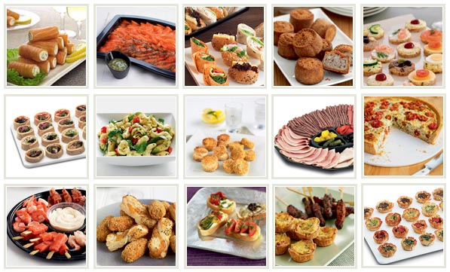
Press Release Body: Waitrose has announced the launch of their new range of seasonal fine foods with something to suit all tastes and budgets.
As the credit crunch drives the appeal for home entertaining and dining, those watching the pennies this festive period can still enjoy the finest foods with the fresh party collection from Waitrose.
The new range offers an exciting collection of 38 contemporary canapés, with something to suit all tastes.
This latest range includes bite-sized classics from around the world, such as traditional styled classics with British recipes like Mini Beef Wellingtons, and Mini Yorkshire Puddings filled with beef, onion relish and crème fraîche with horseradish and mustard.
The Mediterranean collection includes Scallop and Chorizo Skewers, which are hand-made with slices of spicy Spanish chorizo and succulent scallops, marinated with roasted peppers, Sunblush tomato paste and parsley. Other Mediterranean favourites include the ever popular Brie and Cranberry Parcels, as well as Mushroom and Mascarpone Cups, Mini Bruschettas and Lamb Koftas.
The Oriental flavours which are on offer include Mini Salmon Fishcakes with a garlic and ginger dip, Mini Duck Spring Rolls, Spiced Chicken and Cashew Cakes and Paper Prawns.
The new Christmas recipes party food collection will be available in Waitrose branches from November 17th ensuring anyone can lay on an impressive buffet spread for their New Year’s celebration with minimum effort.
All items are suitable for home-freezing too, so they can keep be kept in the freezer through Christmas and into the New Year, and of course all come with the assurance that they are made with the highest quality ingredients.
The new party food collection will be available in Waitrose branches from November 17th About Waitrose Waitrose has 191 branches in its estate including stores in Wales and Scotland and has just been named Britain's Best High Street Retailer at the Which? Awards 2008 and Supermarket of the Year by the RSPCA at its Good Business Awards in 2008. The food shop has won more major wine awards than any other retailer and was named Supermarket of the Year 2007 at the Decanter World Wine Awards.
Waitrose sells over 1,700 organic products, over 60 different types of fish and seafood and more than 100 different cheeses. The food shop also enjoys one of the best reputations for dealing with farmers and suppliers
Web Site: http://www.waitrose.com
Contact Details: Charlotte Hutley
The SPA Way
4 Leathermarket Street
London
SE1 3HN
0207 403 6900

