Wall Street Meets Main Street At Junior Achievement Of Orange County’s 5th Annual Stock Market Challenge
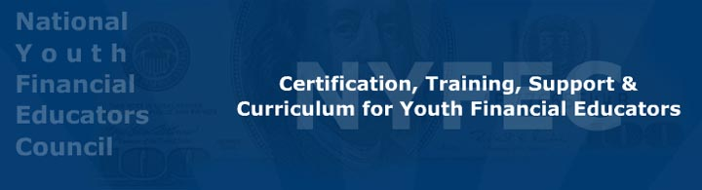

Released on: October 01, 2008, 8:05 am
Press Release Author: Michelle Foote
Industry: Financial
Press Release Summary: High school students and company executives compete head-to-head while learning how the stock market operates. This high energy environment gives young participants a real world understanding of the financial markets and the proceeds will benefit JA’s economic education programs.
Press Release Body: Costa Mesa, CA. The Newport Beach Marriott will be transformed into Wall Street as Junior Achievement (JA) of Orange County hosts the 5th Annual Stock Market Challenge. This fast paced evening of trading excitement will help raise money for JA’s economic education programs and provide high school participants with a hands-on financial education.
Maria Hall-Brown from KOCE will be the emcee as high school students from Corona Del Mar, Newport Beach, and Santa Ana to learn about the stock market by being part of a competing stock trading team.
Vince Shorb, founder of the National Youth Financial Educators Council and a Junior Achievement Board of Directors member, states “With the recent volatility of our financial markets it is vitally important that today’s youth are empowered with a deeper understanding of how the stock market operates.”
Major supporters of JA’s Stock Market Challenge are Wescom Credit Union - Presenting Sponsor, Wells Fargo - Opening Bell Sponsor, 3M - Closing Bell Sponsor, Comerica - Dinner Sponsor, Sam’s Club - Media Sponsor, Grant Thornton, LLP - Marketing Sponsor, and Best Buy - Prize Sponsor. Some of the participating companies are: Citizen Business Bank, Deloitte & Touche, LLP, Irwin Union Bank, Mendoza Berger & Company LLP, Mullin TBG, Orange County Board of Education, ClearLight Partners, LLC, US Bank, and Washington Mutual, Bank of the West and Ross Equipment and Process Solutions Co.
JA Worldwide is the world’s largest organization dedicated to inspiring and preparing young people to succeed in a global economy. For more information on Junior Achievement programs contact Christine Shewbridge, President of JA of Orange County at (949) 515-1998. http://orangecounty.ja.org
The National Youth Financial Educators Council empowers today’s youth with real world financial education and entrepreneurship skills through edu-tainment products and events that are designed specifically for young adults. http://www.NYFEC.org
Web Site: http://www.NYFEC.org
Contact Details: Junior Achievement
301 East 17th Street Suite 202
Costa Mesa, California 92627
(949) 515-1998
MFoote@JASoCal.org

