Zimplit released the easiest website creation tool ever made

Released on: October 9, 2008, 5:30 am
Press Release Author: Mattias Lepp
Industry: Software
Press Release Summary: Zimplit.org has released Zimplit, an Open Source web-based content management system (CMS) that drastically changes the way people create and manage their websites. Unlike other CMS applications that require advanced technical skills, Zimplit enables you to create professional websites, without being a web developer or hiring one.
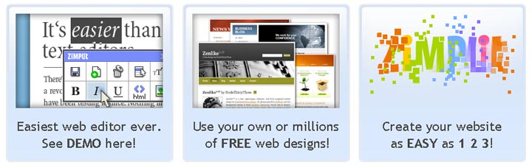
Press Release Body: Zimplit.org has released Zimplit, an Open Source web-based content management system (CMS) that drastically changes the way people create and manage their websites. Unlike other CMS applications that require advanced technical skills,Zimplit enables you to create professional websites, without being a web developer or hiring one.
There are three main reasons that make Zimplit very different from available competitors.
First of all, editing your website is extremely easy, thanks to our "On-site" editor. When you use a normal CMS, you edit your website from the admin area, where you cannot see the real results of the webpage. With Zimplit, the user is on the website like an ordinary visitor, except that on every editable page, user has a small toolbar which makes possible creating pages, changing texts, adding pictures, galleries and videos.
Secondly, you can use any css/html template (design) you wish. Zimplit uses HTML pages as templates and this gives user an opportunity to use thousands of free templates or to choose thousands from design banks.
Thirdly, the installation of Zimplit is easy. Unlike other Content Management Systems, you do not need to install Zimplit. You just have to upload the software on your Internet Service Provider's (ISP's) web server and it’s working.
Zimplit is flexible enough to be used by anyone who wants to build a website. Many entrepreneurs are reluctant to create websites because they believe that site creation and maintenance require a lot of knowledge and effort. With Zimplit, business people can create a professionally designed, multiple-page websites. Teachers can encourage their students to create personal websites and home users can create family websites in minutes.
Zimplit is currently in beta testing, with new functionality being added every day. Later this year, the software will include the ability to add HTML tables, forms, and online gadgets. In addition, Zimplit will provide a hosted version of its CMS, allowing users to run their websites from Zimplit's web servers.
Zimplit is available without charge for home and business use. Business owners who wish to eliminate the online display of the Zimplit legal notices can get a lifetime Zimplitlicense for $49(US). For more information, or to sign up for an account, visithttp://www.zimplit.org.
About Zimplit:
Zimplit is the creation of Krabi & Mask, one of the oldest design agencies in Estonia. Since 1998, Krabi & Mask has been offering web solutions, print design, and digital media solutions for European businesses.
Web Site: http://www.zimplit.org
Contact Details: Contact: Mattias Lepp
Gsm +372 50 70411
Phone +372 744 1210
mattias@krabi.ee
skype: mattiaslepp
www.zimplit.org
Kompanii 10, Tartu, Estonia

