GAME creates innovative new viral game


Released on: November 3, 2008, 9:40 am
Press Release Author: Simon Soffe
Industry: Entertainment
Press Release Summary: GAME has created a brand new online game in which players can win their wish lists from game.co.uk.
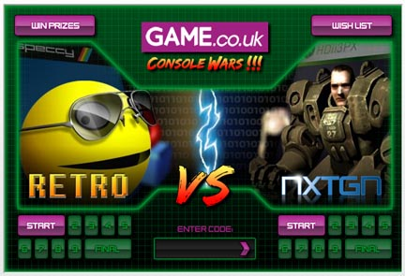
Press Release Body: GAME, Europe's premier video game retailer, has launched a new, innovative advergame where the prize is the player's wish list. GAMEhopes the offer of such a prize will encourage more users to create wish lists at game.co.uk.
Understanding that the campaignwill have to work hard to standout from the crowd, GAME has created a concept that taps into two of the great debates among gamers: which consoles and are the best and who are the best players?
Split between 'retro' gamers who grew up with Pacman and Asteroids and the 'next generation' of consoles, such as the Wii and Playstation 3, players can choose which team they want to represent.
To ensure a successful and high quality campaign, GAME commissioned the winners of the Games category at the New Media Age Effectiveness Awards 2008, 4T2 Multimedia, for consultancy and production. 4T2 split their staff into two groups of different age ranges to produce stylised content for each of the teams in the campaign creating a passionate and competitive development.
With ten levels in the initial launch of the viral game, the campaign from GAME has a long lifespan and will be generating repeat visits for many months. Levels 1 – 7 can be played from all over the web while levels 8 -10 are only available for play on game.co.uk. Each level includes hidden crates that players can find which was tied into a weekly competition, enabling GAME to keep talking to players and give the gamers and bloggers an additional storyline to find and share where the crates were hidden.
The "Console Wars" viral game also features an integrated communication plan for all players in the form of a weekly branded e-mail containing hints tips and links to strategy guides. Players who have not yet set up a wish list will receive a custom e-mail reminding them to do so otherwise they won't win any prizes.
The winner of "Console Wars" will receive a grand prize of £1000 worth of their wish list while five runners up will win £200 of their wish list. Each time a level is completed the player doubles their number of entries into the prize draw.
GAME has created "Console Wars" in such a way that new levels can easily be added and expanded. The video game retailer plans to engage in debate with users to find out what new characters should be added and help shape the game's future.
GAME hopes the combination of great playability and the company's interaction with players of "Console Wars" will encourage users to create their Christmas wish list at game.co.uk in the hope of winning the grand prize.
About GAME:
GAME is Europe's leading specialist retailer of computer software and video games. The Group currently operates from over 400 stores in the UK and Eire and 400 stores in continental Europe and Australia. For further corporate information log onto www.gamegroup.plc.uk.
Web Site: http://www.game.co.uk
Contact Details: PR Contact
Simon Soffe
Head of Investor Relations and Group Communications
Unity House
Telford Road
Basingstoke
Hampshire
RG21 6YJ
01256 784000
www.game.co.uk

