New MMA Clothing Lines and MMA Gear at Official Pro Sports


Released on: November 19, 2008, 7:08 am
Press Release Author: Keoki Kaine
Industry: Apparel & Fashion
Press Release Summary: Official Pro Sports Expands Inventory to Include Triumph United Styles, ADX Fight Wear, Extreme Pain
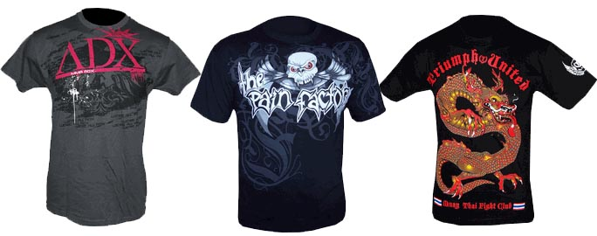
Press Release Body: (Murrieta, CA) November 18, 2008 – Official Pro Sports, a leading retailer of professional sports apparel and equipment today announced the addition of many new lines of MMA clothing including top brands such as Chess Game Fight, Extreme Pain. Representing a collection of up and coming contenders in the world of Mixed Martial Arts, Official Pro Sports has captured the essence of what makes the ultimate fighting industry so engaging for fans of all ages and backgrounds. From Triumph United and ADX to Extreme Pain and Sprawl, Official Pro Sports brings forward the hottest brands in MMA clothing and a MMA Gear. You can find MMA shirts from The Pain Factory and Chess Game Fight wear among others.
Featuring top fighters such as Kimbo Slice from EliteXC, Mayhem Miller WEC Fighter, Rampage Jackson UFC Fighter, Team M, Tiki WEC Fighter, and Sokoudjou. The addition of these new lines provides competitors and fans with a variety of comfortable styles and quality threads to practice, compete or simply represent. Official Pro Sports seeks to be the source for professional sports apparel and like many of the fighters of MMA today, the online retailers has quickly made a name for itself among its competition. As part of its low cost shipping policy, Official Pro Sports offers five dollar shipping on all United States orders and seven dollar shipping on all Canadian orders.
"Adding to our selection of MMA clothing, a MMA Gear, and MMA Shirts, has been a continuous effort. We aim to stay ahead of the trends and bring style and value to world of MMA," said Keoki Kaine, spokesperson for Official Pro Sports. "Offering competitive prices on top brands, we seek to bring the underground world of MMA clothing to the masses. We couldn't be happier with the recent activity revolving around MMA gear,"Kaine concluded.
Official Pro Sports offers the benefit of one stop shopping for MMA gear and MMA clothing supporting a variety of fan gear across the professional sports and mixed martial arts arena.
As a multidimensional supplier of sports apparel and equipment, Official Pro Sports carries a number of brands in MMA clothing, UFC gear, NFL, MBA, MLB, NHL, Elite XC and motorsports apparel, gear and equipment. By providing low cost shipping rates and competitive prices, Official Pro Sports provides everything you need to "keep it official". For more information on Official Pro Sports, please visit http://www.officialprosports.com.
About Official Pro Sports
Official Pro Sports is a leading online retailer, providing professional sports apparel and equipment for MMA, UFC, WEC, NFL, MLB, NHL, NBA, Elite XC and motorsports. The company takes pride in being a single source for athletic apparel including MMA clothing, a UFC Gear, fight & sports apparel, as well as many other items offering serious athletes official apparel and equipment to compete like professionals. With headquarters in Murrieta, CA, Official Pro Sports is a privately held company. Founded in January, 2008 Official Pro Sports has quickly become a key player allowing customers to "Keep it Official with Official Pro Sports." For information about Official Pro Sports please visit the company's web site at http://www.officialprosports.com.
Web Site: http://www.officialprosports.com
Contact Details: key@officialprosports.com
909-810-1155
PO Box 66
Murrietta, CA 92564-0066

