Yukka Fills Gap In Urban Fashion With Own Range


Released on: November 6, 2008, 8:10 am
Press Release Author: Yukka.co.uk
Industry: Apparel & Fashion
Press Release Summary: BRITAIN'S premier online urban clothing boutique is filling a void in the niche area of streetwear fashion by launching its own branded clothing range.
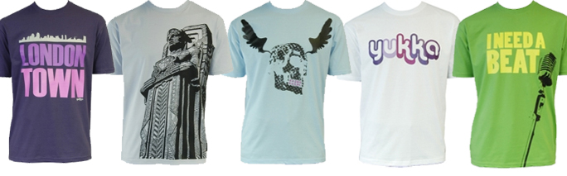
Press Release Body: YUKKA FILLS GAP IN URBAN FASHION WITH OWN RANGE
BRITAIN'S premier online urban clothing boutique is filling a void in the niche area of streetwear fashion by launching its own branded clothing range.
With traditional shops under pressure because of the economic downturn, the new range from Yukka will retail at between £10 and £15, plugging a gap in the market.
The launch collection features 22 different high quality t-shirts with on trend edgy designs which will be sold exclusively through the online Yukka group consisting ofwww.yukka.co.uk, www.yukkadeluxe.com and now www.yukkaUSA.com.
Yukka's managing director Robby Sur said: "This collection meets the demand in the market at a price point level for customers looking to buy into the exclusive nature of today's streetwear and urban brands.
"Each piece will be limited 300 units worldwide with no re-runs, with new designs turning over every 6-8 weeks"
"The range represents a change in our business model, allowing us to progress towards a more controlled distribution channel and create a much more commercially viable and scalable business."
The brand will sit next to other exclusive streetwear brands from, among many others, Ed Hardy, Addict, Ecko, RocaWear, L-R-G, Artful Dodger, Junk Food and Converse.
See the new Yukka range at http://www.yukka.co.uk/.

Web Site: http://www.yukka.co.uk
Contact Details: For further information, please contact:
Robby Sur on email RobbySur@yukka.co.uk

