Can Electrical Pollution Make Kids Fat?

Released on: December 18, 2008, 7:46 am
Press Release Author: Arbor Books
Industry: Environment
Press Release Summary: Pollution can make your child obese, according to the latest study conducted by Barcelona’s Municipal Institute of Medical Research and reported in the Acta Paediatrica journal.
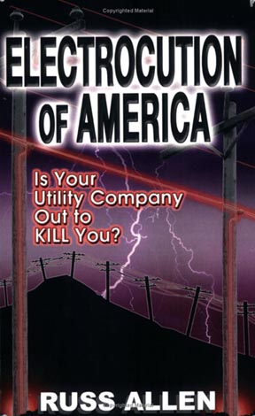
Press Release Body: (DEPERE, WI)—Pollution can make your child obese, according to the latest study conducted by Barcelona’s Municipal Institute of Medical Research and reported in the Acta Paediatrica journal.
While this study links chemical pollution to extreme and debilitating weight gain, one American expert wonders if electrical pollution might be having the same effect on children in the USA.
Russ Allen, author of the new book Electrocution of America: Is Your Utility Company Out to Kill You?, says, “Isn’t it time to conduct non-utility-funded studies here in America to see what kind of effects stray electricity is having on our people?”
Stray high voltage is current that travels through the earth on its way back to the substation. Up to eighty percent of this stray voltage travels through our homes, offices, schools, farms, streets and playgrounds. This means that children as well as adults, including pregnant women, are highly exposed to electrical pollution in every day life.
Stray voltage has been linked to shocks and even death in humans and animals.
In the Barcelona study, it was clearly shown that exposure to a range of common chemicals while in a mother’s womb can cause a baby to grow up fat. The researchers speculated that pollutants may have made the mothers diabetic, which would increase the chances of their children becoming obese.
Mr. Allen’s concern is that electrical pollution can produce the same insidious results.
“Stray voltage might be having profoundly negative effects on people’s bodies,” he says. “California has taken steps to deal with this form of pollution, but only recently. And they are the only state doing so. It’s time the rest of the country’s politicians and public health officials took this threat to our national health seriously.”
Russ Allen is a leader in the movement against electrical pollution. He is also an advocate for increasing unbiased government and academic studies of stray voltage’s harmful effects on humans and animals. He won a multimillion-dollar lawsuit against Wisconsin Public Service for the damage the utility company caused because of the poor design of its electrical distribution system—a design that is common across North America.
Electrocution of America: Is Your Utility Company Out to Kill You? can be found on Amazon.com, BarnesandNoble.com, Borders.com, PriceGrabber.com and Ecampus.com.
For more information, contact the author directly at allen4568@sbcglobal.net.
GLENMORE BOOKS and author Russ Allen chose Arbor Books (www.ArborBooks.com) to design and promote Electrocution of America: Is Your Utility Company Out to Kill You? Arbor Books is an internationally renowned, full-service book design, ghostwriting and marketing firm.
(Electrocution of America: Is Your Utility Company Out to Kill You? by Russ Allen; ISBN: 0-9779685-0-2; $22.95; softcover; 5½” x 8½”; 406 pages; GLENMORE BOOKS)
Web Site: http://arborbooks.com
Contact Details: Arbor Books, Inc.
244 Madison Ave, #254, New York, NY 10016
Contact: Olga Vladi
Phone: 212-956-0950 E-mail: info@arborbooks.com

