Carphone Warehouse reveals an array of gifts for Christmas 2008

Released on: December 4, 2008, 5:24 am
Press Release Author: Carphone Warehouse
Industry: Retail
Press Release Summary: Carphone Warehouse has revealed the variety of gifts available from the retailer this Christmas.
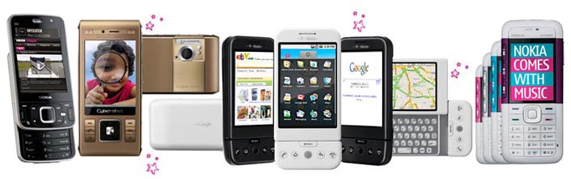
Press Release Body: Carphone Warehouse, the UK's largest independent mobile phone retailer, has revealed the full range of products that will available for shoppers this Christmas.
An extensive range of handsets, laptops and accessories will be on offer from the Carphone Warehouse including the new Nokia N96. Updated from the N95, this slider phone boasts 16GB of memory, allowing plenty of space for multimedia applications, and a 5 megapixel camera.
Also available this Christmas is the Sony Ericsson C905 Inca, the latest handset to offer an eight mega pixel camera that features auto focus, face detection, red eye reduction and both a Xenon and photo flash. As well as the camera, this handset also has in built GPS, 2G of expandable memory and 3G capabilities.
The new Nokia 6600 Slide is also set to be a popular choice of handset this Christmas, offering a sleek look and the latest technology. This Nokia comes with music playing capabilities and a camera as well as the unique addition of a built in accelerometer, which allows users to do things like activate the time on the display or silence inbound calls simply by tapping on the phone twice.
The T-Mobile G1 is available from the Carphone Warehouse this festive season too, allowing users to do almost anything online such as viewing YouTube videos, search on Google, shop online or check e-mail. This handset comes pre-loaded with Google Maps, Google Mail, Google Talk and GPS and is updated automatically via the always-on internet connection.
Smartphones such as the Blackberry Bold and the Samsung Omnia are also available, offering users the chance to download videos and music, take high quality pictures and use applications to meet both business and leisure needs.
As well as the variety of handsets on offer from the Carphone Warehouse this Christmas, the mobile phone retailer also has a range of laptops and accessories available including the Webbook, a lightweight and portable laptop with a 10.2 inch screen that runs on either Linux or Windows XP and offering integrated Wi-Fi, web browser, 3 USB ports and 80GB of hard disk space. Bluetooth headsets utilising the latest technology and the brand new Flip video camcorders, which allow video footage to be uploaded almost instantly to the web, will also be on sale this Christmas.
A wide range gift ideas for technology aficionados is available at the Carphone Warehouse this Christmas with laptops, handsets, accessories and gadgets available to suit any needs.
About The Carphone Warehouse
The Carphone Warehouse is Europe's leading independent retailer of mobile phones and services, with over 2,400 stores in 9 countries. Over the past 5 years, The Carphone Warehouse has built up a significant Telecoms business, which already contributes half of the Group's revenue and is set to be a major driver of future profitable growth.
Web Site: http://www.carphonewarehouse.com
Contact Details: For further information please contact:
Ollie Thomas
freud communications
55 Newman Street
London
W1T 3EB
020 3003 6473
www.carphonewarehouse.com

