Celerant Technology Acquires Well Known Sporting Goods Software Provider
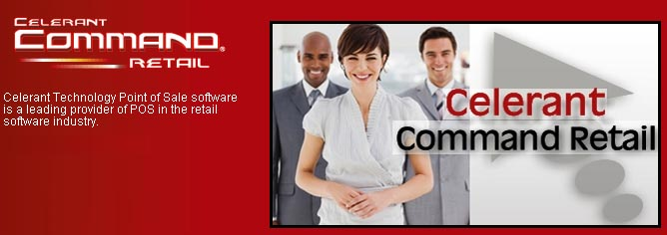
Released on: December 19, 2008, 5:18 am
Press Release Author: Celerant Technology Corp
Industry: Software
Press Release Summary: Celerant Expands Business with Acquisition of SportzPak
Press Release Body: Staten Island, NY (December 18, 2008) – Celerant Technology, a leader in the retail software industry, recently completed the acquisition of SportzPak, a specialty management system. SportzPak provides services for team sports retailers, which will add to Celerant’s growing list of vertical markets.
“The acquisition of SportzPak furthers our efforts to apply our technology towards the individual needs of different vertical markets,” stated Ian Goldman, Celerant President and CEO. “By working with SportzPak, we develop expertise in the team/retail business, and our software will grow to reflect this expertise. As a result of this transition, the Sportzpak clients will benefit from the latest technology, while maintaining the high level of industry specific functionality they need to further their business. Obviously we are all very excited about the progress this new venture brings to everyone concerned.”
The SportzPak product, developed by Miami Valley Solutions, Inc. (MVS), has over 20 years of specialized experience in the sporting goods/team industry and is used by over 210 team dealers. The software itself was designed to meet the needs of the retail and or team dealer by providing control over margins and inventory, aiding in order fulfillment and establishing improved customer service.
“This opportunity to merge cutting edge technology and industry expertise should yield a win-win combination for the Sporting Goods Dealer,” said Greg Helman, MVS SportzPak President and Developer. “The sporting goods dealer will now have the opportunity for a high tech team/retail service including integrated e-commerce.”
Celerant Technology provides a completely integrated, advanced retail solution that reaches across a variety of retail markets. The combined experience and ingenuity ofCelerant and SportzPak will provide a more sophisticated solution to all of their clients, while maintaining excellent customer service and technical superiority. The acquisition ofSportzpak will allow Celerant to continue to grow and the company looks forward to pursuing additional acquisition opportunities of this nature.
About Celerant Technology
Celerant’s Command Retail is an advanced real-time retail management system, which manages all areas of retail including POS, Inventory Management, Warehouse, Distribution Center, Allocation, Multi-Channel/E-Commerce/Kiosk, Data Mining, and Back-office, in a single, integrated system. Our advantage is the flexibility of our Java platform, allowing Celerant professionals to conduct cost-effective analysis and adaptation based on the individual needs of each retailer. The result is a better system that meets the needs of retail businesses and gives them the tools to take Command of their success. For additional information regarding Celerant Technology go to www.celerant.com. For more information about the Command Retail Product, please visitwww.commandretail.com.
###
Web Site: http://www.celerant.com
Contact Details: 4830 Arthur Kill Rd
Staten Island, NY 10309
718-605-7733
718-317-6948
info@celerant.com

