Marrison Properties Launches Marbella Real Estate Website

Released on: December 19, 2008, 5:15 am
Press Release Author: Guy Marrison
Industry: Real Estate
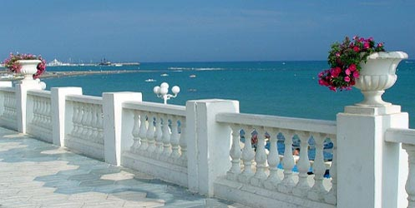
Press Release Summary: Marrison Properties Launches Marbella Real Estate Website
Press Release Body: Costa del Sol, Spain (December 18, 2008) - Marbella is a charming little town located in Costa del Sol, one of Spain’s most well-known coastal regions. A resort town, it is dotted with many luxurious beaches, swimming pools, golf courses, night clubs, and other recreational facilities. The rich and well-heeled are frequent visitors of Marbella, either flying in from halfway around the world or owning one of the villas in the place. Business moguls, Hollywood and Spanish celebrities love to spend a weekend or two in this beautiful seaside town.
Aside from its beaches and watering holes, Marbella is also distinguished by its beautiful real estate properties done in the romantic designs characteristic of Spanish architecture. There are many villas, penthouses, apartments, flats, townhouses, and business establishments all around town—rustic yet sophisticated getaways from all the worries of the world.
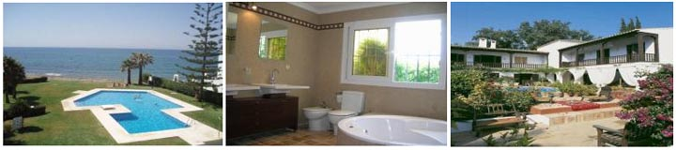
You might wonder: How can I own one of them? Short of going to Spain yourself and contacting a local real estate agent to see what’s for sale, you can check out your prospects first by visiting the website of Marrison Properties. Marrison Properties doesn’t only have properties located in Marbella in their listing, but also those in Ojen, Golden Mile, Malaga, and Sierra Blanca among others.
"Our aim is to make the purchase of your property in Marbella and around the Costa del Sol an enjoyable one, as it should be, and to put as much time as is needed into finding the right place—villas, apartments, townhouses, flats, penthouses, inland country property, whatever it may be that you are looking for in the Marbella area," says Guy Marrison, the owner of Marrison Properties.
Parallel to this goal, the firm has several services that you can avail of. First, they have several detailed guides to help you with the decision to purchase a property. There’s a buyer’s guide, a seller’s guide, the specifics on the purchasing cost, and how to employ a currency dealer.
Once you have decided to do business with them, they have many services to assist you with the processes involved in buying Spanish property. From buying and selling the property, renting it, to project management, furniture packages, property valuations, property surveys and property management, Marrison Properties will be there for you. In addition, they can assist you in choosing a mortgage plan and buying insurance for your home.
Their website has most of the information that you need. Pictures of the properties and their prices are posted in the site. If you’re looking for something specific, you can also use the search function embedded in the website. Marrison Properties also has a blog where you can read about the latest news on Marbella real estate and leave comments and suggestions. Of course, you can also reach them at the contact details provided.
Marrison Properties is a flourishing real estate firm in Marbella, Malaga. For more information, please visit www.marrisonproperties.com
Web Site: http://www.marrisonproperties.com
Contact Details: Guy Marrison
Marrison Properties
Voice 0034 952 774 174
Fax (34) 952 77 66 87
info@marrisonproperties.com
http://www.marrisonproperties.com

