Mastering Dragon NaturallySpeaking for Version 10 Released
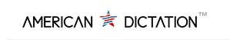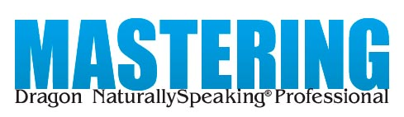
Released on: December 16, 2008, 4:40 am
Press Release Author: American Dictation Corporation
Industry: Software
Press Release Summary: American Dictation releases "Mastering Dragon NaturallySpeaking Professional" for Version 10, an update to their widely successful book on Version 9.
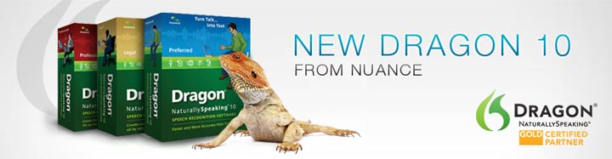
Press Release Body: CARLSBAD, CA -- American Dictation Corporation, the leading retailer of professional digital dictation, transcription and speech recognition solutions in the USA, releases the latest version of its book, "Mastering Dragon NaturallySpeaking Professional," now updated for Version 10. This latest edition of their widely popular self-instruction book is available today at http://www.Learn-Dragon-NaturallySpeaking.com.
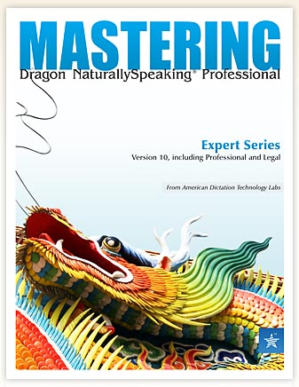
The new Version 10 edition adds 40 new pages, plus updates existing chapters to include the latest changes to Nuance's Dragon NaturallySpeaking Professional, Legal and Medical versions. "We have worked hard over the past weeks integrating the new and exciting features of Dragon 10," says American Dictation President/CEO, Bret Williams, "It was important to us to keep our customers and other Dragon users well equipped to take full advantage of all Dragon NaturallySpeaking has to offer."
The book, according to the Web site, was developed to help people learn Dragon NaturallySpeaking, a powerful, yet somewhat complex software program. "Dragon is very powerful," says Nick Williams, Senior Technical Engineer, "and because it is so powerful, it's easy to miss many of its features and configurations is you don't know what you're looking for." Dragon NaturallySpeaking is not distributed with comprehensive printed manuals.
"Mastering Dragon NaturallySpeaking Professional" is one in a series of "Mastering" guides by American Dictation. Williams says there will be more coming soon on a variety of topics relating to digital dictation and voice-to-print technologies. The book series is produced by American Dictation Labs, a product testing, evaluation and training arm of American Dictation.
The new version is 237 pages and includes helpful hints from American Dictation Lab pros, alerts and warnings to help prevent costly mistakes, step-by-step instructions for all key tasks and guides for using Dragon with popular applications.
The book is a PDF file which can be purchased and immediately downloaded at www.Learn-Dragon-NaturallySpeaking.com. According to Williams, the book is usually priced at $49, but is available now at an introductory price of $29. "We're also giving purchasers a very considerable discount on a special recording device that works especially well with Dragon," says Williams.
Web Site: http://www.Learn-Dragon-NaturallySpeaking.com
Contact Details: American Dictation Corporation
7446 Trigo Lane
Carlsbad, CA 92009
866-408-1383
http://www.AmericanDictation.com
info@AmericanDictation.com

