Canadian Foundlocally.com Adds Eco-Content To Its Community Websites
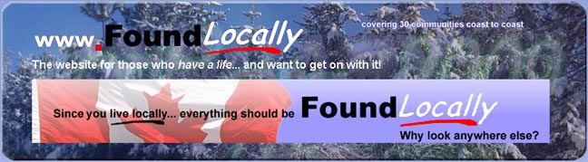
Released on: January 19, 2009, 5:32 am
Press Release Author: FoundLocally.com Media Inc
Industry: Media
Press Release Summary: FoundLocally.com Media Inc, a creator of 30 community information portals has just added over 250 pages of content addressing the environment and ecology, and how it impacts the way we work, learn, shop, eat, play, and travel.

Press Release Body: FoundLocally.com Media Inc, a creator of 30 community information portals has just added over 250 pages of content addressing the environment and ecology, and how it impacts the way we work, learn, shop, eat, play, and travel. The content is indicated by our Going Green graphic:
Most people don’t realize that there's a lot more you can do, than simply using compact flourescent bulbs in your home (the “good start” advocated by TV host David Suzuki), or driving a hybrid automobile. Good environmental practices affect every aspect of our lives. “We initially planned to create a new Environment section in our website,” said FoundLocally founder and General Manager Mark Ruthenberg, “but realized quickly that environmental best practices can—and should—be implemented everywhere. So we integrated our eco-content into every section of our web site.”
FoundLocally’s in-depth content attracts visitors (both our regular visitors who’ve bookmarked out site, and those starting on global search engines), informs them, and then directs them to local businesses and community groups. Visitors can search by category, area, by name or address to quickly find & filter close-by providers of goods & services they seek.
Local environmental tourism businesses, organizations, and community groups can add themselves to each community’s FoundLocally Directory and posting their own descriptions, marketing information, and business categories. Business can also provide a comment about the Environmental practices in their directory entry. This service is FREE, and especially suited to both businesses that don’t have a web site, as well as those that have a website, who also get a free link to their own website, improving their Web Marketing results. All listings can also post events, jobs, savings, and new announcements. To add your local establishment to FoundLocally’s Free Listings, go to http://www.FoundLocally.com, select your community and click on “Free Listings”
Communities now covered by FoundLocally include: Victoria, Vancouver, Fraser Valley, Okanagan, the Rockies, Calgary, Edmonton, Saskatoon, Regina, Winnipeg, Thunder Bay, Sault Ste Marie, Sudbury, Barrie-Muskoka, Kitchener-Waterloo, Hamilton, Niagara Falls, Oakville-Burlington, Mississauga, Etobicoke, Toronto, Scarborough, North York, York Region, Oshawa-Durham, Ottawa-Gatineau, Fredericton, Halifax, Charlottetown, and St John's.
For more information contact Mark Ruthenberg, FoundLocally’s General Manager a 403-245-2194 or by email at mark@foundlocally.com
Web Site: http://www.foundlocally.com
Contact Details: 1600-144-4th Avenue SW
Calgary, Alberta, Canada, T2P 3N4
403-245-21945 fax: 403-237-5551
mark@foundlocally.com

