TS2 Satellite Technologies Offers Global Internet Communication Services
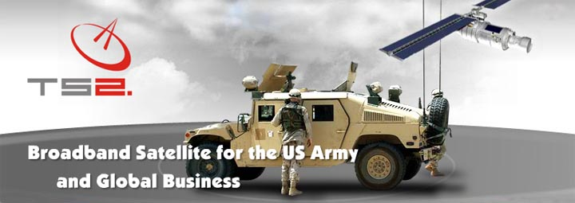

Released on: January 7, 2009, 5:15 am
Press Release Author: TS2 Technologie Satelitarne
Industry: Telecommunications
Press Release Summary: TS2 Satellite Technologies http://www.ts2.pl launches new portable modems for Inmarsat BGAN global satellite broadband network. The operator’s new offer includes all available terminals such as TT Explorer 110/ 300/ 500/ 700, Hughes 9201 and SABRE. The devices are designed for persons and companies who require mobile communications while working or operating in areas that have no cellular networks or ground-based telecommunications.
Press Release Body: Global access to secure broadband satellite services, e-mail, high-quality simultaneous audio and video transmission in real time, two-way data transfer up to 492 Kbit/s (Hughes 9201, T&T Explorer 700), ISDN and VoIP telephone interfaces, SMS with granted independence and unlimited mobility. You will find it all in the new TS2 portable BGAN terminals.
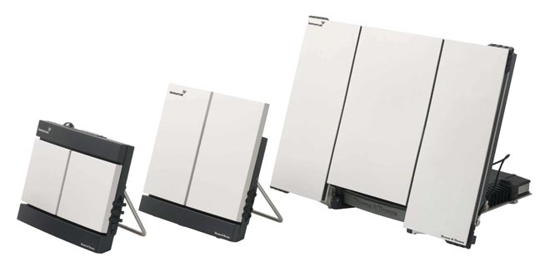
BGAN (Broadband Global Area Network) http://www.ts2.pl/en/BGAN satellite modem is a small laptop-sized device which weighs less than a kilogram (T&T Explorer 110) and which ensures transfer and reception of files of any size within a satellite network from almost any place on Earth. Equipped in USB, WLAN, Bluetooth and ISDN - BGAN makes a control unit or communications center with a decision centre in any place in the world. On land, water, or in the air, both high in the mountains and on deserts – BGAN makes your portable office ready for work within minutes.
BGAN terminals http://www.ts2.pl/en/BGAN are gaining more and more interest, particularly among foreign correspondents, soldiers, crisis management units, police, fire brigades, emergency services and other safety services. Travelers, participants of exotic expeditions, extreme sports lovers, sailors and officers of international organizations all over the world also form a numerous group of users.
The new technology can be used for communications even in most extreme weather conditions. The terminal is resistant to water, humidity, shock, dirt and temperatures ranging from -40ºC to +80 ºC. Its additional accessories such as a solar panel, car antenna or power generating unit eliminate additional limitations. Its user-friendliness and possibility to connect several computers and other compatible devices to one modem make it suitable for use in countless situations.
TS2 Satellite Technologies and Polish branch TS2 Technologie Satelitarne specialize in providing global satellite access services. The most significant clients of TS2 include: the United States Marine Corps (USMC), the United States Army Corps of Engineers and Australian Defense Forces (ADF).
PDF brochures
Thrane & Thrane EXPLORER 110™ http://www.ts2.pl/pdf/Terminal_Thrane_110.pdf
Thrane & Thrane EXPLORER 300™ http://www.ts2.pl/pdf/Terminal_Thrane_300.pdf
Thrane & Thrane EXPLORER 500™ http://www.ts2.pl/pdf/Terminal_Thrane_500.pdf
Thrane & Thrane EXPLORER 700™ http://www.ts2.pl/pdf/Terminal_Thrane_700.pdf
HNS 9201™ http://www.ts2.pl/pdf/Terminal_Hughes_9201.pdf
Wideye SABRE 1™ http://www.ts2.pl/pdf/Terminal_Wideye_Sabre_1_EN.pdf
Picture - GIF 1,0 MB http://www.ts2.pl/images/inmarsat-bgan-ts2.gif
Web Site: http://www.ts2.pl/
Contact Details: TS2 Technologie Satelitarne
LIM Center, XV floor
Aleje Jerozolimskie 65/79
00-697 Warsaw, Poland
http://www.ts2.pl
email ts@ts2.pl
phone +48 22 630 70 70
fax +48 22 630 70 71

