Advanced Crystal Technology Enhances Fire Fighter Safety

Released on: February 25, 2009, 4:41 am
Author: FotoLum
Industry: Industrial
FotoLum Reflective & Photo Luminescent Vinyl Fire Service Products Provide Improved Safety for First Responders.
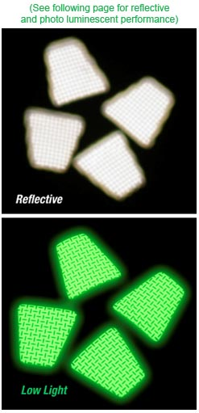
Fire Fighters are a special breed apart. When everyone is running out of a burning building to save their own lives, fire fighters run in, risking theirs to save others. The lethal dangers inherent in dark, smoky spaces are many. Teamwork is critical for survival and success. A key component in teamwork is knowing where everyone is located.
FotoLum – a leading manufacturer of propriety high-grade photo luminescent vinyl combined with 3M light reflective overlay and 3M double backed adhesive designed for fire applications – has already proven that its products save lives. FotoLum photo luminescent and reflective helmet patches, crescents, equipment and SCBA strips perform at such a high level, fire departments using them attest to their effectiveness. 3M's quality adhesive eliminates edge-curling on the patches.
Here's what one fire fighter had to say:
"I have been using the new helmet decals you gave us for a while now. I have had a chance to observe them at 2 fires that we had. In a dark smoke filled apartment fire we had, they were the only thing visible on the firefighters beside me. I have been impressed with their visibility and would recommend them to anyone interested in wearing them."
Roger Joyner – Dallas Fire/Rescue (Please visitfotolum.com/testimonials.html for more testimonials )
FotoLum™ fire service products take safety to the next level by illuminating for hours. By applying the products to uniforms and equipment, entry team members can maintain visual contact in low light and dark, smoky conditions without depending upon a flashlight.
The USA-made FotoLum™ fire helmet trapezoids shown brightly on FDNY helmets in the safe rescue of passengers from US Airways Flight 1549 Airbus after its emergency landing in the Hudson River, January 15, 2009, and have played key safety roles in fire departments around the country.
FotoLum Fire Service Photo Luminescent /3M Reflective Products include:
• Helmet Patches • Helmet Crescents • Letters and Number for Identification
• SCBA Cylinder Patches • Equipment Strips • Custom Velcro backed Shields
All products feature superior performance:
• Charge in any natural or artificial light source
• Fully charged products glow for hours
• Illumination of patches allow team members to maintain visual contact
• Retro-reflective overlay provides a bright white flash to any direct light source
FotoLum™ can customize the products to individual fire department specifications. Patches and SCBA Strips can feature custom lettering, such as city name and even engine number to ensure proper return after a mutual response fire. FotoLum has even provided sequentially numbered labels to facilitate cylinder inventory control.
Firefighter Donation Program
Over the last year, this program has given companies and individuals the ability to thank their local and volunteer fire departments by donating patches to express their appreciation. Patrons simply click on a FotoLum web site link, order the patches and strips, indicate the fire department of choice. FotoLum ships the products out with a certificate of appreciation from the donor.
For more information visit FotoLum.com or contact Nancy Kepko at 913.888.0870.

