Barclaycard creates waterslide game based on advert


Released on: February 11, 2009, 3:32 am
Author: Barclaycard
Industry: Financial
Following the huge popularity of Barclaycard's waterslide advert, the credit card provider has created an online game to help promote their contactless payment method.
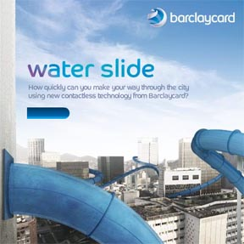
The waterslide game sets users a time limit in which to complete a puzzle to ensure the smooth and safe arrival of the game's character as he travels through a city using a waterslide.
The game is based on thewaterslide advert that sees an office worker cut out the hassle of public transport on his way home as he takes a shortcut by getting a waterslide directly to his house. The video has proved popular on the internet, with more than 1.3 million views and a further 60,000 views for the 'Making of…' video.
The waterslide advert highlights the new contactless credit cardavailable from Barclaycard. This card allows holders to make payments of up to £10 quickly and securely, saving shoppers the hassle of searching for small change. Pre-installed technology on the card means it only needs to be pressed against a secure reader to be activated. There are currently 3000 readers in London and another 3000 nationwide, with the numbers steadily growing.
PIN details will need to be entered occasionally to help protect against fraud and any payments made that are more than £10 will also require the cardholder to enter their PIN, meaning shoppers will have 100% fraud protection on contactless transactions.*
Contactless credit cards, such as the Barclaycard OnePulse, can also come with an inbuilt Oyster card for easy use on London's transport system.
The waterslide emphasizes the smooth, fast transactions afforded to the holder by the new contactless credit card and the online game acts as a gateway to a large collection of information about the new card - with safety and usage tips available.
Notes to editor:
*Cardholder will be liable if they, or any additional cardholder, gives or provides access to the card, account or PIN details which results in those details being used fraudulently.
About Barclaycard
Barclaycard is a multi-brand credit card and loans business which also processes card payments for retailers and merchants and issues charge and credit cards to corporate customers and the UK Government. Barclaycard is one of Europe's leading credit card businesses and has an increasing presence in the United States.
In the UK, Barclaycard comprises Barclaycard, Sky Card, Thomas Cook and Argos branded credit cards and FIRSTPLUS secured lending. Barclaycard also manages card operations on behalf of Solution Personal Finance.
Contact Details:
Barclaycard PR contact:
Joel Davis
Barclaycard Press Office
Barclaycard
1234 Pavilion Drive
Northampton
NN4 7SG
01604 251229
www.barclaycard.co.uk

