Dental Implants California - Dr. Peter Wohrle offers Same Day Dental Implants California - Newport Beach
Released on: February 4, 2009, 3:28 am
Press Release Author: LPI
Industry: Healthcare
Press Release Summary: Dental Implants California – The Wohrle Dental Implant Clinic and Dr. Peter Wohrle are now able to offer patients Same Day Dental Implants at their Newport Beach California Dental Implants Clinic.
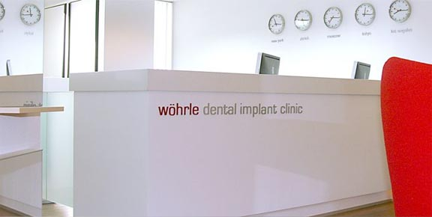
Press Release Body: BACKGROUND: About 22 million people in the United States have dentures or no teeth at all. Dental implants can offer a welcome alternative for those who want to regain their smile. The first modern dental implants hit the scene in the 1950s, and they've improved quite a bit over the years. Dental implants provide a base for replacement teeth that look and function like natural teeth. The implants are tiny titanium posts that are surgically placed into the jawbone where teeth are missing. The bone grows to the titanium, creating a strong foundation for artificial teeth.
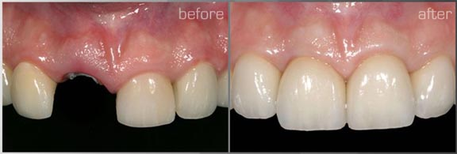
According to the American Dental Association, the number of implants placed by dentists increased 49 percent between 1995 and 1999.
STANDARD IMPLANTS: Typically, dental implants are done in two surgical procedures. The dentist will have to refract (peel back) the gum tissue to see just where the implants will go to avoid sensitive nerves. When the proper placement is decided, the dentist will then place the implants into the jawbone. For the first three to six months following that surgery, the implants, which are just below the surface of the gums, bond with the jawbone. While the implants are bonding with the jawbone, new replacement teeth are made by the dentist. When the implants are fully bonded with the jawbone (again, a process that takes up to six months), the dentist is ready to fit the new teeth. The second procedure you undergo includes uncovering the implants and attaching the posts that act as anchors for the artificial teeth. The teeth are then attached to those posts. The entire process takes up to nine months to complete.
NOW, FASTER, EASIER IMPLANTS: Now, dentists are offering an innovative way to give you dental implants and teeth in a one-hour office visit. At an initial patient visit, doctors take a 3-D image of the patient's jaw using an iCAT machine. When used with new computer software, the images show dentists the exact anatomy of the patient's jaw, finding even the smallest amounts of bone. Dentists can plan the surgery with pinpoint accuracy using these images and eliminate any potential problems before the patient even arrives at the office for the procedure. Dental Implants California
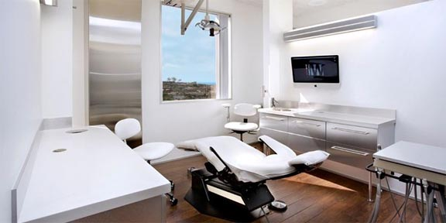
Peter Wohrle from The Wohrle Dental Implant clinics in Newport Beach,California says, “with this new technique, we can treat patients more efficient, with less pain, and more accuracy” Most procedures are done by cutting open the gums. No cutting means less trauma and less pain for the patient. When the patient comes for their implants, it takes about an hour to insert the implants and attach the teeth. Dr. Wohrle says: What used to take months, we often can accomplish now within hours, with much less trauma and better results."
Dental Implants California
Web Site: http://www.dental-implants--california.com
Contact Details: Wohrle Dental Implant Clinic
360 San Miguel Dr.
Suite
Newport Beach, CA 92660
(949)612-2600

