Foreign Translations, Inc. Presenting Sponsor for Japan America Association of S.C. Annual Gala

Released on: February 23, 2009, 12:33 am
Author: Ken Zwerdling - Foreign Translations, Inc.
Industry: International Trade
Greenville, SC, February 23, 2009 – Foreign Translations, Inc.(www.foreigntranslations.com) is the Presenting Sponsor for the Japan America Association of South Carolina (JAASC) Annual Gala on February 28, 2009 at the Westin Poinsett Hotel in downtown Greenville, South Carolina. The JAASC Annual Gala provides an opportunity to the leaders of the region’s Japanese and American business community to gather and network. The commitment of the JAASC organization is to promote cultural awareness and understanding between the United States and Japan. Foreign Translations, Inc. recognizes this cause as an important factor in facilitating the growth of international business in this region, as well as around the world, and is proud to be the presenting sponsor of this event.
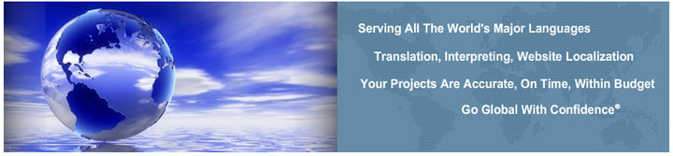
Members of the JAASC attending the Annual Gala are leaders of local international companies including FUJI Film Manufacturing USA, Inc., AFL Telecommunications, Kyocera Mita South Carolina, Inc., Mitsubishi Chemical, and more. Nonmember attendees include local Japanese suppliers and consumers, as well as international companies from the Atlanta and Charlotte areas. JAASC is a statewide, non-profit organization established in 1988 in response to the increase of Japanese-owned businesses in South Carolina. Its membership base includes individuals, corporations, and public sector representatives focused on improving and building international relationships. The JAASC has seen great success in fostering these connections through the organization’s Japanese Saturday School, numerous social activities, and international events in conjunction with the International Center of the Upstate.
The JAASC Annual Gala is independently funded and made possible due in part to the support of sponsors such as Foreign Translations, Inc. Ken Zwerdling, CEO of Foreign Translations, Inc., will be available during the evening to discuss the local international community and how this company participates in its advancement. Foreign Translations, Inc. feels privileged to take part in this event, and many similar events, which encourage the development of the international community in Greenville and surrounding areas. For the past 11 years, Foreign Translations has been providing Japanese translations for companies such a Fuji, Lehman Brothers, Rockwell Automation, Juniper Networks, ePrize, and Estee Lauder.
About Foreign Translations, Inc.
Foreign Translations, Inc. (www.foreigntranslations.com) is an 11- year old foreign language translation, interpreting and website localization firm headquartered in Greenville, SC. The company offers Japanese translation services as well as other languages for a wide range of projects; from technical manuals, legal contracts and marketing collateral to financial statements, training manuals, e-learning courses, websites, medical journals, software, policy and procedure handbooks, newsletters and much more. With more than 1,000 native translators located in over 30 countries, we frequently translate documents from 1,000 words to over several million words in all the major languages of the world. In addition, we provide interpreters for depositions, trials, sales meetings and conferences in every major city in the United States as well as every major country in the world. We also offer a full range of Multilingual Desktop Publishing Services in any format and any size.
Contact Details: Foreign Translations, Inc.
55 Beattie Place - Suite 205
Greenville, SC 29601
864-272-0480
www.foreigntranslations.com
kzwerdling@foreigntranslations.com

