Jim Shore’s Angels Are Now Part Of Artistic Checks’ Masterpiece Collection


Released on: February 13, 2009, 7:25 pm
Author: Stephanie Demetriou/Artistic Checks
Industry: Marketing
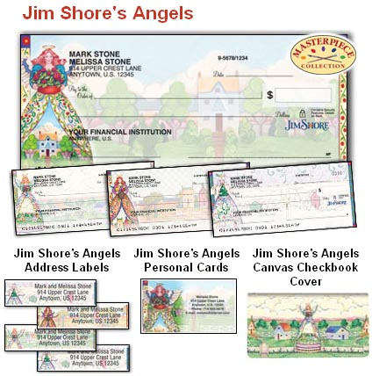
Through its Masterpiece Collection, Artistic Checks has been able to showcase the artwork of many well-known artists on checks and other banking accessories. Artistic Checks continues to expand its assortment of Masterpiece personal checks with the addition of Jim Shore’s seasonal angels.
Artistic Checks is thrilled to have the work of such a talented artist on its personal banking products. Jim Shore is known worldwide for his stone resin figurine works of art resembling hand-carved wood, folk art paintings and country décor home accessories. This award-winning artist has loved creating artwork since as far back as he can remember and it truly shines through in his work. Artistic Checks is proud to be offering his artwork in another format for his collectors to enjoy.
In February, 2009, Artistic Checks launched its new product suite, “Jim Shore’s Angels,” through its Masterpiece Collection onwww.artisticchecks.com. The personal checks and address labels feature four rotating designs of angels, which represent the four seasons, against landscapes of peaceful, country towns. The paintings are infused with folk-art colors and patterns that give them a very country décor look. The product suite also offers a personal contact card and printed canvas checkbook cover also featuring Jim Shore’s angel artwork.
For over a decade, Artistic Checks has offered the artwork of many well-known artists and painters. The masterpieces of Jim Shore are sure to expand the collection in a new and exciting way as Artistic Checks continues to grow. Visit the site today to view all the outstanding designs available on personal checks and other checking accessories.
About Artistic Checks:
Artistic Checks is known for its assortment of artwork on personal checks. Many artists have their work portrayed on these products as another way for admirers to enjoy their art. With a variety of works available on their products, Artistic Checks has something for everyone. Browse through the collection to find something you love.
Contact Details: 1802 Fashion Court
Joppa, MD 21085
410-679-3300 ext.2453
410-676-3300 (Fax)
sdemetriou@cdi-us.com
http://www.artisticchecks.com

