Npower host the Climate Cops programme in Worcester
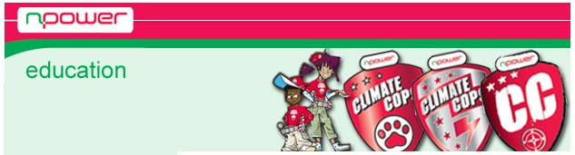
Released on: February 17, 2009, 3:08 am
Author: Npower
Industry: Energy
npower, one of the UKs largest energy providers, has been hosting the 'Climate Cops' programme, which visited Worcester's Powick C.E Primary School in an effort to help the school become greener and more sustainable.
Over 52 pupils in years 4 and 5 were involved in the Climate Cops Academy which helps children learn how to become greener at home and in school in a fun and engaging way. The highly interactive day was filled with activities, including generating electricity with body movement, working with miniature examples of renewable energy sources and using thermal imaging cameras to see how much heat is emitted from human body and the effects of insulation.
Worcestershire County Council has been working closely with npower for over 12 months on the Climate Cops programme, helping schools throughout the local area. The scheme follows the Government's National Framework for Sustainable Schools and forms a key part of npower's Brighter Futures Programme which aims to inspire young people from the first day of school to the first day of work and brings npower's education programmes under one umbrella.
The Climate Cops programme can also provide schools with 'green makeovers', including free energy audits, helping to implement tailor-made energy efficiency measures to reduce a school's carbon footprint.
Head teacher at Powick C.E Primary School, Mr Richard Drewett, said:"The Climate Cops Academy has taught the children about climate change and saving energy in a really fun way. They've learnt some simple ways to conserve energy that will make a big difference to the school, their homes and the environment."
Rupert Brakspear, Learning for Sustainability Officer at Worcestershire County Council added: "It's great to see a class of children so excited, exploring ideas around energy and climate change. I'm certain the experiences they have had during the Climate Cops Academy day will give them plenty to think about over the coming weeks ahead. It is the small things we can all do that add up to making a big difference and we hope this programme will work with other schools in the city to help reduce the overall amount of energy used."
This year, six other schools and over 375 children in Worcester will experience Climate Cop Academies, including; Cherry Orchard Primary, Turves Green Primary, Fairfield Community Primary, Upton upon Severn Primary and Great Witley Primary School. Lyppard Grange Primary School has already benefitted from the initiative at the start of the year.
Teachers and children can go to the Climate Cops website at www.climatecops.com for interactive games and downloadable activities. Teachers can also visit www.npowerbrighterfutures.com to order their copy of the Climate Cops teaching resources that bring education for sustainable development, science, geography and citizenship to life.
About npower:
npower is one of the UKs largest electricity supplier and draws on 50 years experience in supplying electricity and gas. npower offers a range of essential home and business services to 6.6 million customers across the UK.
npower PR Contact:
Greg Phillimore
Account Director
McCann Erickson
Communications House
Highlands Road
Shirley
West Midlands
B90 4WE
0121 713 3795
www.npower.com

