Old World Gourmet receives two FIRST PLACE awards!

Released on: February 23, 2009, 12:34 am
Author: Creative Web Solutions: Free Website Design
Industry: Food & Beverage
Old World Gourmet received a First Place Award for Best New Gourmet Gift with their Party In A Pitcher!! They have taken their line of already consumer friendly bar mixers, put it in the actual pitcher you make it up in, gift wrapped it, and it's ready to go! The pitchers are trimmed out with coordinating colors to match the bar mixer inside. The Margarita Pitchers are done in bright greens, the Cosmopolitans are in hot pink.....the Frozen Wine Chillers are in burgandys, sage and golds.......you get the picture. Absolutely THE Perfect Hostess Gifts.
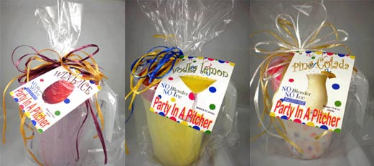
Old World Gourmet also received First Place in the Best Snack Category for their Simply SINsational Trail Mix. They combined freshly roasted and lightly salted pecans, almonds, cashews, brazils, macadamias, pistachios, hazelnuts and peanuts and then added FRIED GREEN PEAS! Mama said..........eat your peas and what a way to eat your peas! It's packaged in assorted bandanas tied with jute string. A great snack mix with a keepsake bandana!! This item is a great basket inclusion, perfect for Father's Day, and can even be assembled in your favorite "GAME DAY" colors! This is simply The Best Snack in town!
Old World Gourmet has been in the business of selling frozen wine chillers for 6 years. Dan and Deanna Sullivan attribute the success of their company to the grace of God, commitment to succeed, and always exceeding our customer’s expectations. “Success for us is truly measured by our customer’s complete satisfaction.” Deanna states.
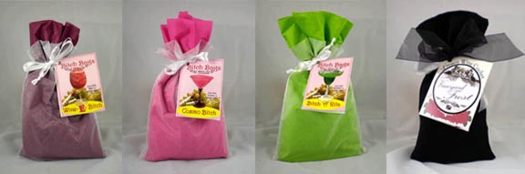
Old World Gourmet actually made its debut on September 11, 2001... (Yes that date is correct). Dan reflected back to the day the business started, “We were in Philadelphia at the National Candy Show. Certainly we will never be able to forget that day.”
Old World Gourmet will be celebrating their 6th year in business on September 11, 2007. “Our parent company "Nuts for You" started in 1996 in Florida with two products, cinnamon and sugar glazed nuts and my grandmother’s "church punch" which later became our signature "Old World Cider". Deanna reminisced By providing a high quality line of products and designing their own packaging and marketing strategies, It is no wonder that within the last five (5) years Old World Gourmet has reached a regular customer base just over 4000. They manufacture all of their products from the actual item to the custom bags that they go into. All are hand-crafted and hand assembled one bag at a time. Merchants who have developed a working relationship with Old World Gourmet are able to take advantage of their private labeling for resellers. If there is a frozen wine cooler on the market, it likely got its start at Old World Gourmet.
Old World Gourmet has been featured in The Home Business Magazine which highlights "self-made" business individuals. Some of their products such as our Vineyard Frost and their Margarita have been featured in magazines such as Rave Reviews and Country Business. Their products can be found in locations such at The Atlanta Hartsfield-Jackson Airport, Tampa Airport, Orlando Airport, Hallmarks,Theme parks, Boutiques, Hospital gift shops, and hundreds of retail shops.
Excitedly Deanna announces the new line of products that just hit the market. “Our Wine @ Five Collections(TM) of frozen wine chillers is a must! The hottest NEW Frozen Wine Drinks are here. Vineyard Frost, a refreshingly different way to cool down on a hot summer day! Just add our Vineyard Frost, your favorite wine, and mix, freeze and enjoy! No blender or ice needed. We are also the home of the "BITCH BAG" Collection of frozen Wine Mixes. That’s right, the “BITCH BAG” collection! THE BITCH IS BACK and she is at Old World Gourmet! Hot off the production line from Old World Gourmet, their new "Bitch Bag Collection" is breaking record sales. The powdered mix collection consists of all the favorites, “Wine-E-Bitch", "Bitch-ARita", "Cosmo Bitch", "Lemon Drop Bitch" and "Bitchy Colada".
For a delightful and unique wine tasting party, mix with your favorite wine, freeze about 3 hours, wire whisk and instantly become the best host/hostess in town! A frozen wine way ahead of its time!
These "Bitches" are here to stay. Come on now..................you know you WANT ONE!
Contact Details: Old World Gourmet Shop
1680 Hiram/Douglasville
Suite 302
Hiram, GA 30141
1-877-466-8889

