Saving Your Marriage, The Alternative To Counseling Way
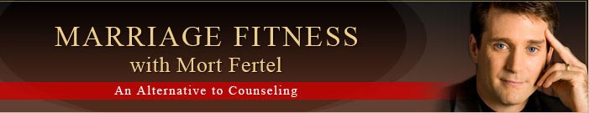
Released on: February 25, 2009, 12:45 am
Author: http://www.marriagemax.com
Industry: Human Resources
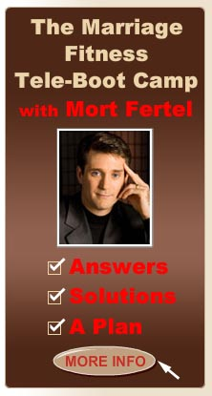
Baltimore, Maryland, February, 2009 – Visit Mort Fertel’s website and just tell him – “Save my marriage, Mort!” His methods and materials are private and easily accessible to anyone, worldwide. There are many free advice tips on how to save your marriage, on his website. A visitor to the site will be able to sign up for Email advice and also look at the mini-articles there.
People have to like themselves before they can love each other, and Mort Fertel’s amazing new alternative to marriage counseling, called Marriage Fitness, is a wonderful way to start back on the right path of saving your marriage.
Included in the course are seven sessions of Tele-Boot-camp, fifteen CDs and a journal and private one-on-one phone conversations. The Marriage Fitness Audio Learning System is a five CD audio experience designed for the person or couple who want to be economical or cannot afford to spend too much money at one time, but are vested in Marriage Fitness. It's also for the person or couple that wants to test out a portion of the program before taking the plunge. It's a great program that costs under $100. Step-by-step instructions about how to renew your marriage are described by voice, and explained fully. Although not nearly as comprehensive as the other two programs and you won't get any professional counsel or direct access to Mort, this program alone has saved thousands of marriages.
Couples who have taken Mort’s Marriage Fitness program have said it’s a life changing experience. Others have said it gave them a new perspective on failing marriages. One couple said their marriage had become unbearable and Mort Fertell changed their life. Many, many married couples have gone through marriage counseling. Some have been helped and some have not. Mort Fertel’s Marriage Fitness program has helped thousands of people keep their marriages, and themselves, intact.
Mort Fertel has been on many network news programs and has been featured in lots of magazines. He has been telling people about his new Marriage Fitness program and how it can help people in making their marriages more vibrant and indeed, how it can save marriages from going awry. People have felt inspired when listening to Mort’s CDs. Mort also has a Marriage 911 call center set for urgent and crisis situations.
If you are visiting Mort’s site for the first time, check on the section called Today’s Advice. It can give you an instant uplift. Don’t forget to sign up for the free Email newsletters while you are there. Look at a few testimonials. See what other people have found in Mort’s program that is so unique and fresh. Mort’s Marriage Fitness Tele-Boot Camp is fully explained on the site. This could be considered the meat and potatoes of his advice, along with the complete CD course on fifteen CDs, These CDs are great because you can learn and listen as you drive to work, or are simply puttering around in the house.
Mort is a world authority on the psychology of relationships and has a world-renowned reputation for saving and helping marriages. Besides working with couples, he teaches individuals how to single-handedly transform their marital situation. If you are healthy and marriage-aware because of Marriage Fitness, it may serve you well in your next relationship. Get healthy first, just like when you go to a gym, because being healthy in a relationship is the best feeling in the world.
Even if you feel your marriage is steady, it may not hurt to take the courses with your spouse or partner. After all, even though we may feel we know everything about our marriage, taking Mort’s Marriage Fitness course can only improve on a good thing. In addition it may avert any little thing that could turn into a much bigger problem sometime in the future of your marriage.
For additional information on the news that is the subject of this release, contact Mort Fertel at either (410) 764-1552, or visit his website at http://www.marriagemax.com.
About Marriage Fitness with Mort Fertel: Mort Fertel graduated from the University of Pennsylvania, was the CEO of an international non-profit organization, and a former marathon runner. He lives with his wife and four children (including triplets!) in Baltimore, Maryland. He can show you how to save your marriage.
Contact Details: Marriage Fitness with Mort Fertel
3410 Bancroft Road
Baltimore, MD 21215
(410) 764-1552
http://www.marriagemax.com

