npower reveals a saucy TV appearance from Wallace and Gromit
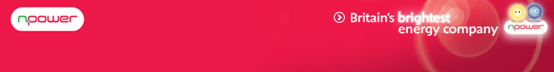
Released on: March 24, 2009, 5:36 am
Author: Lucy Hart
Industry: Entertainment
Npower has revealed it's the first time family favourite has appeared in the buff but he’s spared his blushes by an enterprising Gromit.
In the 30 second npower advert Wallace suffers the ultimate bathroom hardship when the pair's home boiler breaks down and his hot shower runs cold. A startled Wallace turns to Gromit for his help. The clever hound gets on the 'dog and bone' and calls out npower’s hometeam to replace the boiler.
Wallace's appearance marks the first of a series of npower adverts starring the duo that will appear on screen for the next two years. Each ad will be characterised by the famous pair doing what they do best and inventing hair brained schemes to help their home be more energy efficient.
The ad, which airs on the evening of Saturday 28th March, aims to highlight how Britain’s brightest energy company is helping make energy efficiency easy and fun.
The advert took five weeks to film and 10lbs of modelling clay was used to create the scenes and characters. The npower hometeam van seen in the advert is a working model that has suspension, moveable windscreen wipers, hinged doors and wind up and down windows. The new advert also sees the debut of Hometeam Bob, the latest character to be added to the Wallace & Gromit cast.
Joan Coe, Head of Brand Communications at npower, comments: "Wallace and Gromit are the most famous film pairing in Britain. Their cosy personas and 'have a go' approach to energy efficiency is what we need to help people see how simple it is to make small changes but a big difference to their energy bills."
About npower:
npower is one of Britain's largest electricity supplier and supplies gas, electricity and related services to 6.6 million customers across the UK. npower is a market leader in renewable energy and sources the green energy for juice directly from renewable sources, at no extra cost.
RWE npower has been awarded the prestigious CommunityMark from Business in the Community (BITC). npower is the only utility business, amongst 21 other companies in the UK, to receive this accolade. The CommunityMark is a new BITC standard which has been created to recognise companies that are good investors in local communities and who have brought about real and positive changes.
For further information, interviews and images please contact:
Lucy Hart
PR Executive
Oak House
Worcester
WR4 9FP
0207 693 7421
www.npower.com

