Office Partitions Expert Optima Systems Unveils Two New Products To Its Glass Partitioning Range


Released on: May 14, 2009, 6:25 am
Author: Laura Jameson
Industry: Construction
The glass partitioning specialist has engineered two new glass doors which can be used in seamless conjunction with Optima’s other glass partitioning products.
LONDON, UK: Optima Systems’ team of technical engineers have come up with two exciting new products to add to the Optima range.
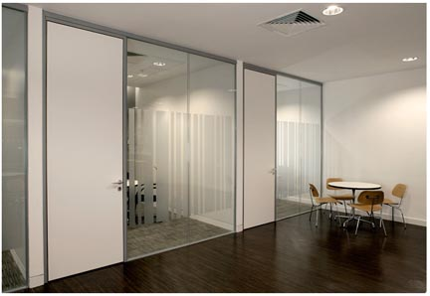
The two new glass doors are designed to glide smoothly open, saving precious office space and creating a sophisticated and sleek office aesthetic.
The two new products, the Framed Sliding Door and the Pocket Sliding Door, are very different and can be used in conjunction with different Optima glazing systems.
Traditionally, sliding doors and acoustic performance do not go hand in hand, but Optima’s new Framed Sliding Door ensures that this design dilemma is a thing of the past.
The minimal aluminium frame of the Framed Sliding Door incorporates full length brush seals at the head and base and compressible seals on the vertical ‘door stop’ edge for an enhanced acoustic performance.
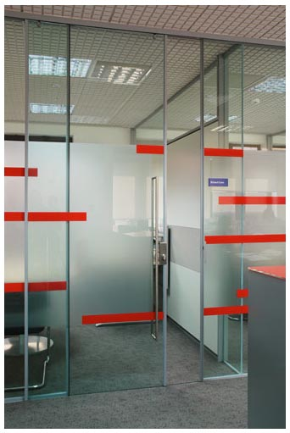
The door is operated by pull handles which run on Optima’s ever popular Kinetic dual trolley rolling system. The base detail incorporates a discreet anodised channel to fully control the door’s travel, thus eliminating the potential for leading edge drift and ensuring a light yet solid operating feel.
Optima’s Framed Sliding Door is the perfect way to form a space efficient office entrance within Optima’s 117 single glazed partition system, without compromising on acoustic performance.
Optima’s Pocket Sliding Door provides an attractive solution where minimal detailing, space efficiency and acoustic performance are important considerations.
The door was designed as an addition to our popular Revolution 97 double glazed mullion-free partition system. The 12mm glass leaf door is suspended from Optima’s highly popular and proven Kinetic operating system which enables the door to glide effortlessly into the double glazed screen.
The door is designed to be operated by pull handles, providing the benefit of upgrading to floor deployment lockable handles if necessary.
For more information on any of the Optima product range, visit http://www.optimasystems.com/.
**ENDS**
About Optima:
Optima offers the highest quality service and innovative design to secure consumer satisfaction, ensuring that their extensive range of partitioning systems are able to meet customers’ exacting specifications, supported by technical expertise to achieve successful project completion.
For more information on Optima Systems or the Optima product range contact:
Laura Jameson
Courtyard House
West End Road
High Wycombe
Buckinghamshire
HP11 2QB
http://www.optimasystems.com
marketing@optima-group.co.uk
01494 492600

