BabyBox.com Announces the Arrival of Sweet Beginnings Baby Furniture and Little Bunny Blue Crib Bedding

Released on: June 15, 2009, 4:26 am
Author: Babybox.com
Industry: Retail
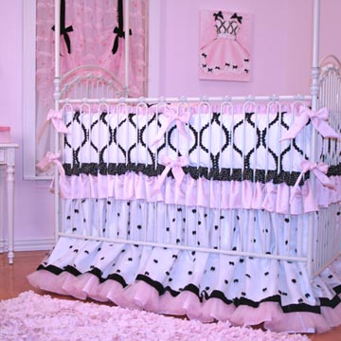
Luxury baby retailer adds furniture from children’s lifestyle pioneer and new baby bedding collection
(Darien, Conn.) June 12, 2009 -- www.BabyBox.com, a luxury retailer of high-end crib bedding, baby furniture and baby gifts, today announces the arrival of Sweet Beginnings children’s bedroom furniture and Little Bunny Blue bedding collections. Both Sweet Beginnings and Little Bunny Blue carry on the time-honored tradition of outfitting nurseries and children’s rooms with artisan-quality furniture and linens crafted, with tender loving care, for infants and children.
“Sweet Beginnings is a pioneering force in children’s furniture and our selection of heirloom quality furniture would not be complete without the impeccable designs from creator Patrice Flashner Fitzgerald,” said Katherine Type, founder of BabyBox.com. “Adding the finishing touch to any nursery is made fun and easy with exclusively designed crib bedding offerings by Little Bunny Blue, which boasts one of the most extensive selection of unique styles available today.”
Universally recognized for its superb styling and craftsmanship, Sweet Beginnings line of children’s furniture features cribs, changing tables, toy chests, beds, nightstands, dressers, armoires, desks, storage consoles, shelving units, bookcases, mirrors, and hand painted wall décor. The Sweet Beginnings furniture collection combines traditional and modern design lines with sophisticated, fun and whimsical artwork. Assisted by a team of talented craftsmen and artists, renowned children’s lifestyle designer, Patrice Flashner Fitzgerald, mother of two, manufactures and hand-paints each and every piece of Sweet Beginnings’ furniture.
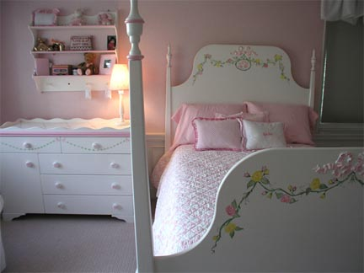
Examples of Sweet Beginnings signature combinations include sleigh cribs with bear and blocks illustration, big top circus or nautical sail away theme. Book cases are sturdy and designed with as much imagination as the stories in the books, featuring extra deep pockets to hold a child’s favorite books for years to come. Sweet Beginnings beds are elegantly designed with a variety of styles including four posters to day beds, and come in twin, double, queen and king sizes.
Dressing a crib has never been more fun and enchanting than with the crib bedding collection from Little Bunny Blue. The Chanel crib set is inspired by none other than the famous designer herself, with pink, white and touches of black to create elegance for the ultra chic baby. The Bella crib bedding set perfectly outfits a princess themed nursery, with 18-inch gathered dust ruffle accented in elegant pink, sage and cream trim, while the Miss Princess crib set is equally suitable for a princess or ballerina nursery: white silk taffeta adorned with embroidered pink flowers and soft green vines graced with pink double faced satin ruffles and crib ties. The gathered dust ruffle features pink satin ribbon topped with pink tulle. The Sebastian crib bedding set in a new toile pattern adds a rustic charm to nurseries while its silk and cotton linens are complemented by a gorgeous plaid crib skirt and ties.
Little Bunny Blue crib bedding can be ordered as a set: bumper, fitted sheet, coverlet and 18-inch dust ruffle, or à la carte. Matching diaper stacker, boudoir pillow, toy bag, window treatments, moses baskets and cradle linens are also available. To finish off the nursery, Little Bunny Blue also offers bed crowns fit for princes and princesses.
For a limited time, Babybox.com is offering free shipping and a complimentary boudoir pillow with any Little Bunny Blue crib bedding purchase.
From developmental toys to baby clothing, crib bedding and nursery furniture, BabyBox.com features an A-list of upscale designers, such as House Inc., Henry & Henrietta, Lulu DK Matouk, Lulla Smith, Gordonsbury, Serena & Lily, Blauen, Sweet William, Lullaby and Baby B, among others.
About BabyBox.com
BabyBox.com is a premier baby gift store for children, ages newborn to 12 months. Offering a specialized selection of luxury baby items, the company prides itself on serving a niche market with a focus on unique and high quality products including
adorable baby clothes, crib bedding, nursery décor, quality children's furnishings, baby furniture, custom baby bedding, Moses baskets, bassinets, handmade items, as well as baby gifts, such as toys, baby blankets and keepsake gifts. In addition to the specialized infant collections, BabyBox.com has expanded its offerings to provide furniture, bedding, décor and clothing for older children. With headquarters in Darien, Conn., BabyBox.com has provided unique baby gifts since 1997. For more information, please visit www.BabyBox.com.
# # #
Contact Details: Katherine Type
Founder/President
(203) 655-0185

