Household Energy Bills to Hit Almost GBP5k in 10 Years Time

Released on: June 24, 2009, 8:44 am
Author: uSwitch.com
Industry: Energy
Consumers are being warned today that they could be facing annual energy bills of almost £5,000 a year by 2020. The shock forecast from uSwitch.com, the independent price comparison and switching service, is based on pricing trends over the last 5 years and takes into account the huge investment programme shortly to be undertaken by the energy industry and Government. The investment, expected to total £233.5 billion, will secure the country's longer-term supply and enable the roll-out of smart metering into all homes, but will add £548 a year onto household energy bills for the next 15 years.
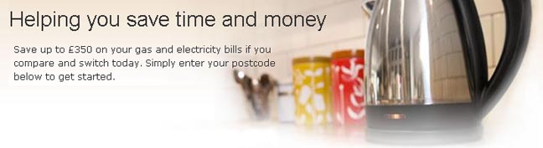
Looking at pricing trends alone, consumers could expect energy bills to reach £4,185 by 2020. This strips out the cost of investment, but factors in inflation and volatility in the wholesale markets, as seen by suppliers over the last 5 years. Since 2004, global demand for energy and volatility in wholesale prices have contributed to a 114% increase in household energy prices, including a 42% or £381 increase last year. The overall effect has been to see household energy bills more than doubling from £580 in 2004 to £1,243 today.
Volatility is expected to continue to be a dominant theme in the energy market going forward. Although the current world-wide recession is dampening demand for energy, the recession is due to end by 2011/12, when global demand for energy can be expected to start climbing again. Power hungry economies, such as China and India, will be returning to strength, resulting in an upward pressure on wholesale energy prices. At the same time, North Sea oil will start to run out adding greater pressure on the market. Wholesale energy prices account for around 50% of a household bill so continuing volatility will have an impact on the amount consumers will pay.
As well as upward pressure on household energy bills, there will be downward pressure too. The Government's drive to make British households more energy efficient will start to pay dividends. But, instead of reducing bills it will serve to counterbalance other factors pushing energy usage up, such as the growth in single person households, Britain's ageing population and growing reliance on electrical gadgets.
Ann Robinson, Director of Consumer Policy at uSwitch.com, says: "This is a wake-up call for us all. The £5,000 a year energy bill may seem like an outside possibility, but we have to remember that energy bills doubled in the last five years alone and that the huge investment needed just to keep the lights on in Britain will alone add £548 a year onto our bills. The fact is we are entering a new era of high cost energy and households will have to adapt their behaviour accordingly.
"The Government has been banging the drum for energy efficiency for a while now, but consumers have been reluctant to spend money on these measures. As a result, energy efficiency has been massively underperforming even though it is one of the biggest defences we have against escalating energy costs. We also have a competitive energy market, and yet less than 5% of consumers are on the most competitive energy plans - most people are paying far more than they have to for the energy they use.
"This has to change. My advice to consumers is to invest in making your home more energy efficient, reduce the amount of energy you use and make sure you are paying the lowest possible price for it. Big projects such as a new energy efficient boiler or home insulation can be expensive, but the savings you make through cutting the price of your energy could be re-invested into energy efficiency measures so that you reap even greater rewards in the future.
"Don't be put off. If cost is an issue, speak to your supplier to see if they can help - they have a pot of money available to help households with energy efficiency. Or contact the Energy Saving Trust for advice. The key thing is to start future-proofing yourself against higher energy bills now."
Contact Details: See the full version of this press release.
About uSwitch:
uSwitch.com is a free, impartial online and telephone-based comparison and switching service, helping consumers compare prices on gas, electricity, water, heating cover, home telephone, broadband, digital television, mobile phones, personal finance products and car insurance.
For more information please contact:
Jo Ganly, uSwitch.com on 0207 802 2915 or joganly@uswitch.com

