JD Sports Launches Exclusive Masters Competition To Win A Carbrini Football Kit


Released on: June 19, 2009, 9:05 am
Author: Kim Jones
Industry: Sports
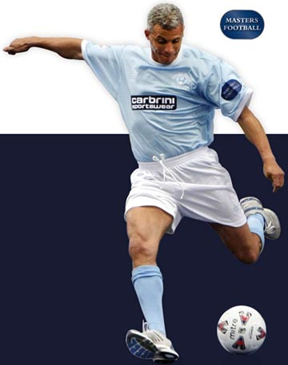
JD Sports' exclusive Cabrini brand is pleased to be sponsoring a number of the teams at this year's events. To celebrate the occasion, JD Sports has hooked up with the guys from Masters to bring an exclusive competition to win a Carbrini football kit for an entire team.
As the Masters Cup celebrates its 10th year of competition this summer, the world's most popular legends football tournament will be coming to 8 regions throughout the UK and JD Sports have a football kit competition for every event. Featuring 40 teams and 360 players, in 8 different cities across the UK, the Masters Cup 2009 represents the pinnacle of indoor football excellence.
The list of legends to have played Masters Football is exhaustive, with new names coming through each series. The London Masters will be taking place on 20th June at Wembley Arena and teams from Arsenal, Spurs, Chelsea, West Ham, QPR and Fulham are taking part with Ray Parlour, Jimmy Floyd Hasselbaink, Tore Andre Flo and Paul Merson just some of the famous faces from the pitch to be seen in action.
The JD Sports football kit competition is open to anyone aged between 10 and 14 years old who wants to share the pitch with some of the all time greats and step up to the spot. The lucky winners will be selected for each regional event to take part in a penalty shootout and the lucky overall winner will take home a team strip for their team from Carbrini. The winner will then be put through to take part in another shoot out in the final of the Masters Cup in September.
Further competition information is available through the website or leaflets in store.
-ENDS-
About JD Sports
JD Sports Fashion Plc is the leading UK specialised multiple retailer of fashionable branded and own brand sports wear and casual wear. It operates from over 450 stores via a number of fascias and offers customers a selection of leading sports brands.
John David Sports was founded in 1981 with one shop in Bury. It expanded into the Arndale Centre in Manchester in 1983 and consolidated its position throughout the 1980s with further openings, largely in the North and Midlands. The first London store was opened in Oxford Street in 1989.
The business continued to grow organically until 2002 and then grew further with the acquisition of over 200 stores, further consolidating its position as the leading and by the time of JD Sports' stock market flotation in 1996 there were 56 stores.
JD Sports PR contact:
Kim Jones
JD Sports Fashion PLC
Hollinsbrook Way
Bury
BL9 8RR
0161 767 1659
www.jdsports.co.uk

