Barclaycard Freedom Retail Partnership Begins To Take Shape


Released on: February 17, 2010, 9:19 am
Author: Barclaycard
Industry: Financial
Barclaycard has announced the national partners that will be joining the tens of thousands of small and medium retailers who have been invited to join Barclaycard Freedom, set to be the broadest retail rewards scheme in the UK. LA Fitness, YO! Sushi, Firebox.com, Goldsmiths and Nationwide Autocentres are initial examples of the retailers signing up to Barclaycard Freedom and will offer reward money to Barclaycard customers when the scheme launches in March.
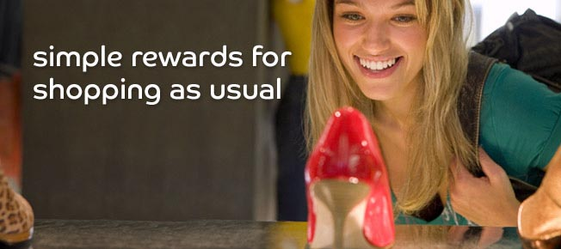
Barclaycard Freedom, the innovative new loyalty scheme, will be available automatically to over eight million Barclaycard cardholders who will be able to earn and redeem reward money at the point of sale, without having to do or remember anything. Reward money is recorded in pounds and pence, with no vouchers or coupons to save and no points to calculate.
Alison Vickers, Business Development Director of YO! Sushi said: "We have been trialling Barclaycard Freedom in a couple of our stores and have been impressed with how simple and intuitive it is. We are very excited to be involved in a programme which rewards our customers for simply using their Barclaycard to pay their bill. The simplicity and convenience of Barclaycard Freedom appeals to our customers, and we are looking forward to being part of the launch in March."
Barclaycard Freedom is simple and easy to use with credit card holders seeing their new reward money balance on the card machine as part of each transaction. The next time the card is used at a participating retailer the current value of the customer's reward money balance will appear on the card machine before they enter their PIN to pay. Cardholders can then choose to redeem some or all of their reward money towards that transaction or continue to save for a future purchase at another retailer within the scheme.
Sarah Newman, Managing Director of Barclaycard Freedom, commented: "Barclaycard Freedom incorporates all of the best elements of loyalty schemes with the rewards, quite simply, in pounds and pence. We are delighted that well known high street and online brands LA Fitness, YO! Sushi, Firebox.com, Goldsmiths and Nationwide Autocentres will be part of Barclaycard Freedom. These retailers each interact with their customers in different ways and represent a wide range of retail sectors, and we will be revealing many more participants in the weeks before launch."
One of the strengths of Barclaycard Freedom is that it offers the concept of a rewards programme to many small and medium retailers for the first time. In addition to household names, over 30,000 retail outlets have been invited to be part of the scheme at launch.
-Ends-
About Barclaycard
Barclaycard, part of Barclays Global Retail Banking division, is a leading global payment business which helps consumers, retailers and businesses to make and accept payments flexibly, and to access short-term credit when needed.
The company is one of the pioneers of new forms of payments and is at the forefront of developing viable contactless and mobile payment schemes for today and cutting edge forms of payment for the future. It also issues credit and charge cards to corporate customers and the UK Government. Barclaycard partners with a wide range of organisations across the globe to offer their customers or members payment options and credit.
In addition to the UK, Barclaycard operates in the United States, Europe, Africa and the Middle and Far East.
Key facts published in February 2010;
- number of UK customers: 10.4m
- number of International customers: 10.8m
- number of retailer/merchant relationships: 87,000
PR Contact:
Andrew Bond
Barclaycard Press Office
Barclaycard
1234 Pavilion Drive
Northampton
NN4 7SG
01604 251229
www.barclaycard.co.uk

~~~~~

Press release distributed via EPR Network (http://express-press-release.net/submit-press-release.php)

