Catalent Scientist To Co-Chair Cell Line Development And Engineering Conference


Released on: February 19, 2010, 3:25 am
Author: Jennings and Co.
Industry: Pharmaceuticals
Gregory T. Bleck, PhD., Senior Director of Cell Line Engineering for Catalent Pharma Solutions, will be co-chairing the Cell Line Development and Engineering conference being held in San Francisco, California on February 25-26, 2010.
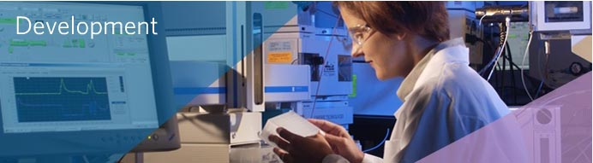
In addition to co-chairing the conference, Dr. Bleck will be presenting "Characteristics of an Effective Mammalian Cell Line Generation Process for Bio-Pharmaceutical Production." His session will explore how steps in the generation of mammalian cell lines have been optimized to make the process more efficient. Dr. Bleck will also outline certain approaches to improve timelines and throughput. Additionally, data collected from Catalent’s development of more than 200 cell lines, each producing a different antibody or recombinant protein, will be reviewed.
Dr. Bleck received his BS and Ph.D. from the University of Wisconsin-Madison, and performed postdoctoral work at the University of Illinois-Urbana working in the areas of gene regulation and expression, and joined Catalent Pharma Solutions in 1998. At Catalent, he transferred his knowledge of gene expression and transgenic systems to the development and continued optimization of retrovector expression systems and is one of the developers of the GPEx® gene expression technology. Dr. Bleck has published over fifty-five research papers and authored three book chapters. He has seven issued patents and eight patents currently under review.
For more information on Catalent’s broad range of biopharmaceutical development services, go to http://www.catalent.com/development.
About Catalent
Headquartered in Somerset, New Jersey, Catalent is one of the leading providers of advanced dose form and packaging technologies, and development, manufacturing, packaging and printing services for pharmaceutical, biotechnology and consumer healthcare companies in nearly 100 countries. Catalent applies its local market expertise and technical creativity to advance treatments, change markets and enhance patient outcomes. Catalent employs approximately 9,100 at 30 facilities worldwide and in fiscal 2009 generated more than $1.6 billion of annual revenue. For more information, visit http://www.catalent.com.
Contact Details:
Dan Dunlop
ddunlop@jenningsco.com
919-929-0225
Patricia A. McGee
(732) 537 6407
patricia.mcgee@catalent.com
~~~~~

Press release distributed via EPR Network (http://express-press-release.net/submit-press-release.php)

