Correct Building Products(R) Introduces CorrectDeck RapidRail(R) CX in Stone White with Microban(R) Antimicrobial Product Protection Provides Aesthetically Appealing Low-Luster Finish and the Warm Look of Painted Wood

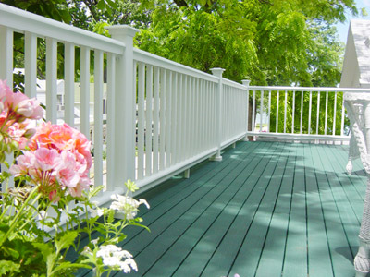
Released on = May 9, 2007, 6:38 am
Press Release Author = Correct Building Products
Industry = Construction
Press Release Summary = CorrectDeck RapidRail(R) CX in Stone White with Microban(R) Antimicrobial Product Protection Provides Aesthetically Appealing Low-Luster Finish and the Warm Look of Painted Wood
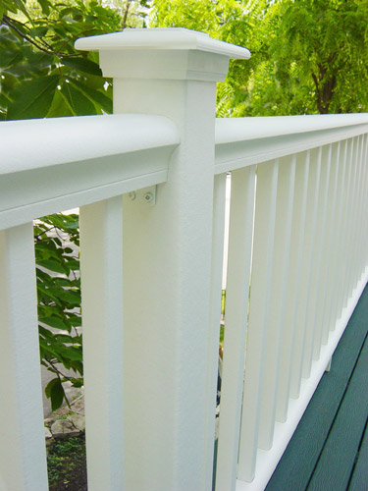
Press Release Body = BIDDEFORD, Maine (May 8, 2007) – Correct Building Products(R) LLC, manufacturer of CorrectDeck(R) composite decking, introduces the newest addition to its product line: CorrectDeck RapidRail(R) CX in Stone White with Microban(R) antimicrobial product protection. This new product has a low-luster finish that provides the warm look of wood, providing a high-end look that complements composite decks. CorrectDeck RapidRail CX is PVC-free and, like CorrectDeck's newest decking product, CorrectDeck(R) CX with Microban(R) antimicrobial protection, is designed to provide enhanced low-maintenance qualities.
Definitely not a plastic rail
“We have improved the aesthetic appeal by providing the warm look and feel of painted wood without the artificial and shiny look associated with plastic railings,” said Martin Grohman, Correct Building Products president. “This is definitely not a plastic rail in appearance or quality. CorrectDeck RapidRail CX provides the heft, weight and feel of lumber, but without the maintenance of wood,” Grohman said. “This is a true hybrid decking material, combining the best of both plastic and wood.”
Antimicrobial, low maintenance and lasting good looks
A co-extrusion process is used to engineer Microban protection into each rail, baluster and post. Microban's antimicrobial properties help prevent the colonization of mold and mildew that can cause stains, odors and discoloration. Microban protection will not wash off or wear away, and makes RapidRail easier to clean, and keeps it cleaner longer. In addition, RapidRail CX resists stains from grills or food spillage because wood fibers are coated with plastic, reducing their exposure. Protection of exposed fibers and the addition of concentrated UV inhibitors enable the railing components to resist color fading.
Fast assembly and installation
RapidRail is designed for speed and ease of installation. A typical eight-foot section is fully assembled with only 16 screws in just 5-10 minutes. The top and bottom rails are precision routed for easy attachment of balusters – no screws are needed. Simple powder-coated brackets and screws are used for hanging top and side rails. All hardware is supplied.
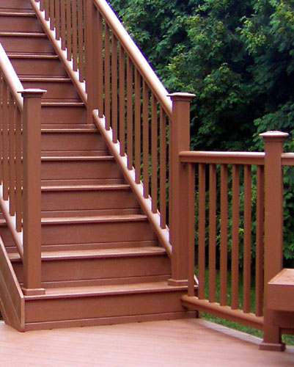
The strength of polypropylene
Like all CorrectDeck products, RapidRail CX is a polypropylene wood composite product, which is stronger and holds its straight shape better than polyethylene or polyvinyl chloride (PVC), especially in hot climates.
New stair kit system
CorrectDeck RapidRail CX in Stone White with Microban product protection features a new stair kit system that simplifies the installation process. The system is designed to hide attachments, giving the railing a clean, screw-free appearance. Balusters have round, hollow centers and utilize a ball connector system which allows installation at any angle.
RapidRail CX in Stone White with Microban antimicrobial protection is backed by a transferable, limited lifetime warranty. Matching accessories are available, such as color-matched, beveled post caps and skirts.
Correct Building Products(R) LLC, headquartered in Biddeford, Maine, is the first and most experienced manufacturer of polypropylene-based composite decking products. Correct Building Products leads the industry with technical innovation in areas of design, formulation and automation. The company's CorrectDeck(R) CX with Microban(R) antimicrobial product protection is the first composite decking to combine antimicrobial protection that resists mold and mildew with stain- and fade-resistance. More information is available at www.correctdeck.com or contact Mike Descoteaux, Correct Building Products, 8 Morin Street, Biddeford, ME 04005, 207-284-5600, miked@correctbp.com.
Web Site = http://www.correctdeck.com
Contact Details = Mike Descoteaux
Correct Building Products
8 Morin Street
Biddeford, ME 04005
207-284-5600
miked@correctbp.com

