Lil'House Heaters Offer an Attractive and Much More Cost Efficient Way to Heat Homes or Shops This Winter With Wood.


Released on: September 21, 2007, 9:27 am
Press Release Author: Scott Bradley
Industry: Energy
Press Release Summary: If homeowners are considering purchasing a outside wood heater, now is the time while manufacturers have product in stock. Winter is fast approaching and heating bills will be rising.
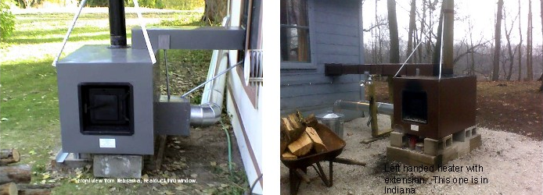
Press Release Body: Ozark, MO September 21, 2007 -- With the heat still affecting much of the USA, sitting back in the easy chair in a warm home is probably the last thing homeowners would be thinking about in late September. However, it is time to be thinking of an alternative heating solution for your home. Instead of letting your money go up the chimney, why not look into a forced air wood burning furnace that sits outside.
Scott Bradley an expert in outside wood heaters at Bradley Enterprises suggests that now is the time to be selecting a heater and getting it installed prior to the heating season.
“Now before fall or winter even arrives is the time to be thinking about what to do with those high heating bills you will have coming.” Scott Bradley says, sales manager of Bradley Enterprises in Ozark, Missouri. “Waiting till late fall is not a good option since demand will outstrip supply of outside wood furnaces like last fall and winter. You will be faced with a long wait for a furnace. This could have you installing on a cold winter day instead of a nice fall afternoon.”
If you have access to wood, and live in a mainly rural area an outdoor wood heater would be the ideal alternative heat source for your home or shop. Always be sure and check with your local zoning board to make sure a unit could be installed on your property.
Several factors that will influence the prices of heating oil, propane, natural gas, and electricity in the upcoming winter season October 2007 thru March 2008 include:
1. China and India and other areas of the world have a strong demand for diesel fuel which is similar to home heating oil.
2. Tight crude supply and political unrest in several areas of the world (Middle East tension, Iran, Nigeria just to name a few places).
3. Hurricane related interruptions in supply.
4. A lack of excess production capacity, in the past other areas of the world could make up for production disruptions in another area. Now, with an increase in demand all over the world the excess does not exist.
5. The amount of winter weather we have as transportation of heating oil can be slowed by snowy roads or frozen rivers.
These are just some of the reasons heating your home could be more expensive this winter season. All the different heating source usually follow one another in pricing during a winter season.
Homeowners that are interested in burning wood in a outside wood heater should find them priced from $1400.00 to $7-8000 dollars it will depend on the style, options or size of the heating unit.
More information on outside heating units can be found online very easily by using a search engine like Google or Yahoo. Looking for information by using “outside wood heater, outside wood furnace, outdoor furnace” will bring up a variety of manufacturers product lines.
For more information on the news included in this release (or an interview) contact Scott Bradley or visit www.outsidewoodheater.com.
About Bradley Enterprises:
In business over 19 years selling forced air outside wood furnaces locally and shipping throughout the entire USA from the website. Number one in sales volume of the Lil’house outside the house forced air wood furnace.
Scott Bradley, Sales Manager
Bradley Enterprises
417-581-7755
http://www.outsidewoodheater.com
# # #
Web Site: http://www.outsidewoodheater.com
Contact Details: Scott Bradley
760 southpaw road
Ozark, Mo. 65721
417-581-7755
sales@outsidewoodheater.com

