Your 1st Choice for Financing Logistics Vehicles or any Commercial Equipment
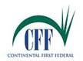

Released on: September 6, 2007, 12:21 pm
Press Release Author: Terry Meeks, Sr. V. P.
Industry: Transportation & Logistics
Press Release Summary: Continental First Federal, a National Lender, becomes a major competitor to most banks and other lending institutions by offering better rates and terms to the Logistics Market.
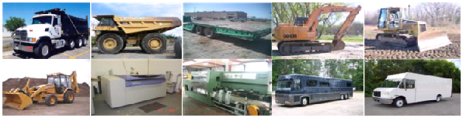
Press Release Body: With over a decade of financing logistic vehicles across America and other equipment such as construction, excavating, logging, paving, etc. Continental First Federal is becoming recognized as a major competitor when it comes to matching rates and terms on financing any commercial equipment including municipal financing rates, which are currently being quoted at 4.14% for most cities and counties seeking financing on their equipment acquisitions. Their company motto is: "Let CFF Help You Grow Your Business", as quoted by their Sr. VP. The company can be contacted by calling toll free at: 1-800-998-8997
Web Site: http://www.continentalfirstfederal.com
Contact Details: Terry Meeks, Sr. VP
Continental First Federal
13018 Lebanon Rd.
Mount Juliet, TN 37122
PH: 1-800-998-8997
FX: 1-877-998-8997
e-Mail: t.meeks@continentalfirstfederal.com

