Totally Fitness to sell the BBC’s Dragons’ Den Doggy Treadmill


Released on: December 11, 2007, 4:12 am
Press Release Author: Totally Fitness
Industry: Retail
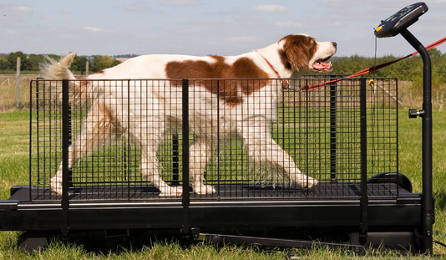
Press Release Summary: The Doggy Treadmill which received funding from BBC “Dragon”, James Caan, is now to be made available for pet owners to purchase through Totally Fitness
Press Release Body: Following a meeting between the new star of BBC’s Dragons’ Den, James Caan and Totally Fitness director, Oliver Zissman, Totally Fitness has decided to add the treadmill range from FitFurLife Ltd to its exclusive list of high quality cardio equipment. This is the first time that Totally Fitness has sold a piece of fitness equipment that was not designed for human use.
But why use a dog treadmill? It is generally understood that a well-exercised dog is typically a well-behaved dog however a regular walk is not always enough. Treadmill training for dogs provides a complete muscle enhancing, toning and fitness regime that not only improves the overall health and vitality of a dog, but helps it curb destructive behavioural problems, increases life span and prevents obesity. These treadmills which are now being made available through Totally Fitness can give a dog a real workout, allows the owner to control the terrain, and eliminate distractions, and the dog can run regardless of weather.
Veterinary Surgeons, professional breeders, showing industry and owners have been using the dog treadmill for a wide variety of training and exercise purposes, particularly rehabilitation post-operative physiotherapy.
Professional breeders use the treadmill for show ring practice and gait analysis, so their dogs are in top show condition. Dogs are often put on a dog treadmill to have their gaits analyzed, so by practicing the gait on a regular basis, breeders can analyze and improve a dog’s chance of winning.
Like doctors treating human patients, vets have been using treadmills to refine post-operative rehabilitation, under controlled conditions, of both medical and surgical operations. This has been demonstrated to dramatically improve the rate of recovery and the end result.
The dog treadmill is highly effective for any type of sporting dog as it is ideal to continue the fitness programme when the weather outside is not permitting.
Owners who have a high energy dog (which results in a badly behaved dog because energy levels aren’t being exerted) use the treadmill on a regular basis, achieving drastic results in the dog’s attitude, thus decreasing barking, biting and chewing.
Totally Fitness have now made the Fit Fur Life Treadmill available through their site in a couple of different sizes as well the Superior Fit Fur Life Treadmill which is the perfect treadmill for professional breeders, and the Professional Fit Fur Life Treadmill for Dogs which is designed for heavy use.
Web Site: http://www.totallyfitness.co.uk/
Contact Details: Totally Fitness PR contact:
Elliot Zissman
Director
Totally Fitness
Unit 7
1000 North Circular Road
London
NW2 7JP
United Kingdom
http://www.totallyfitness.co.uk/
Direct line: +44 (0)20 8438 8515
Fax: +44 (0)20 8830 7109

