Benefect


Released on: March 23, 2008, 8:16 pm
Press Release Author: Universal Botanicals, LLC
Industry: Environment
Press Release Summary: Benefect Botanical Disinfectant and Cleaners.
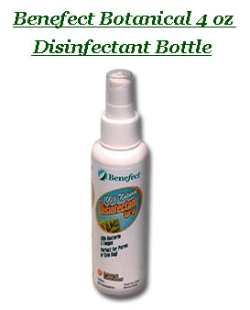
Press Release Body: What is Benefect Botanical Disinfectant?
Benefect is a natural and chemical-free biodegradable disinfectant. It contains botanically pure plant extracts and has been proven to kill over 99.99% of Bacteria, Fungi, TB & HIV. It is approved by the EPA as a high level disinfectant, fungicide, Tuberculocide & Virucide that requires no rinsing or wiping after its application. Thyme Oil, extracted from the Thyme plant, is its main ingredient and component. It is known to kill bacterias such as Staph, E. Coli, Strep, Salmonella and HIV-1. Containing natural germ-killing capabilities, it is ‘Generally Recognized As Safe’ (G.R.A.S.) by the U.S. Food & Drug Administration.
Who is this disinfectant suitable for?
As a natural and chemical-free disinfectant deriving its main ingredient (Thyme Oil) from the Thyme plant, it’s safe to be used around children, pets, the elderly, the chemically-sensitive and those suffering from Asthma and allergies.
Where can this disinfectant be used in the home?
In the home, it’s suitable for countertops, tables, bathrooms, toilets, pet areas, sinks, garbage cans, desks, keyboards, children’s toys, changing tables, food preparation areas and places where mold & mildew tend to grow.
Where can this disinfectant be used publically?
Public bathrooms, office environments, workstations, restaurants, hotels, hospitals, healthcare facilities, medical offices, laboratories, schools, daycare centers, spas and gyms are all suitable areas and places where it can be used.
It is also suitable for water or mold damaged construction materials such as walls and floors, as well as being used for deodorizing porous surfaces such as carpets and underpad.
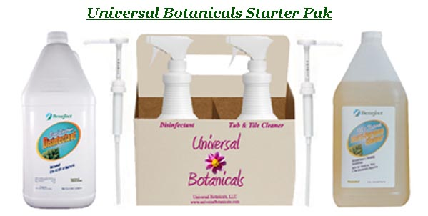
Benefect Disinfectant and Benefect Atomic Cleaner are commonly known to be used in Home and Commercial Restoration as an alternative to toxic products used in restoration services. Benefect Disinfectant is now registered by the EPA for use in air ducts. Benefect Atomic Cleaner contains no VOCs, solvents, petrochemicals, dyes, fragrances, phosphates, alkyl/nonyl phenols or other hazardous or unnecessary ingredients.
It is also known to be effective as a general deodorizer.
For more information on Universal Botanicals and Chemical-free Disinfectants & Cleaners, please visit http://www.universalbotanicals.com or call 1.888.935.WELUVGREEN (935-8847).
Web Site: http://www.universalbotanicals.com
Contact Details: Nicole Mammano
Director of Business Development
Universal Botanicals, LLC
33 Tuxedo Road
Montclair, NJ 07042
nicole@universalbotanicals.com
1.888.WELUVGREEN
1.866.369.0112 Fax

