Orphan, Former Foster Child and Now Doctor of Education, and CEO Authors Self Help Book About Decision Making in All Aspects of Life
Released on: March 11, 2008, 10:15 am
Press Release Author: Colleen Spadt
Industry: Management
Press Release Summary: Now on sale at Amazon.com/BarnesandNoble.com: The first hardcover edition of The Navigator of Life, a series of self-improvement strategies created to empower individuals of all ages and walks of life.
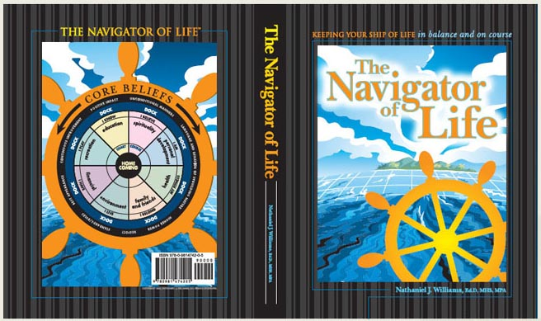
Press Release Body: Orphan, former foster child and now doctor of education, CEO, and author Nathaniel J. Williams, Ed.D, MHS, MPA offers insightful perceptions on how people can best fulfill their personal and professional goals and intrinsically understand how good decisions are made. After the sudden death of his mother, he and 9 of his 11 siblings spent the majority of their youth growing up in environments that demanded resiliency and tenacity. Dr. William’s journey, which includes being a foster parent, entrepreneur, non-profit/for-profit Chief Executive Officer, adjunct professor, scholar-in-residence, motivational speaker and now author, has yielded a breadth and depth of life experience that he is using to improve the world in which we live.
The Navigator of Life is a teaching tool and empowerment process for individuals and an overture to our greater community that, accepted and implemented, has the power to affect dramatic change in a real and lasting manner. The Navigator of Life reinforces a Core Belief structure that includes, but is not limited to, respect, personal improvement and uplifting behaviors. It encourages individuals to question the impact of multiple dimensions such as education, health and personal development on decisions.
And, finally, it advocates learning about oneself through the answers to those questions and using that knowledge to intelligently navigate the twists and turns of everyday life. The Navigator of Life is a simple, straightforward commentary on how all people are possessed of the inherent ability to seize and harness their personal power to enhance, uplift, and expand their potential. In addition to availability in print, The Navigator of Life Companion DVD depicts three life situations in which people are successfully using the program. Illustrative components of the program are available as digital presentation files for professional use. Additional information on The Navigator of Life and free downloads of The Navigator of Life poster and other graphic elements are available at www.NavigatorofLife.com.
For bulk purchases of The Navigator of Life, or to inquire about Dr. Williams’ professional speaking availability for conferences and corporate events, visit www.nj-williams.com or email nwilliams@NavigatorofLife.com.# # #
Web Site: http://www.navigatoroflife.com
Contact Details: CONTACT:
Colleen Spadt
HumanWorks Training and Educational Services, Inc.
484-893-5078
484-893-5079 (fax)
cspadt@hwa-team.com
www.navigatoroflife.com

