Florida Tourist Website Features New Orlando Family Adventures and Theme Parks
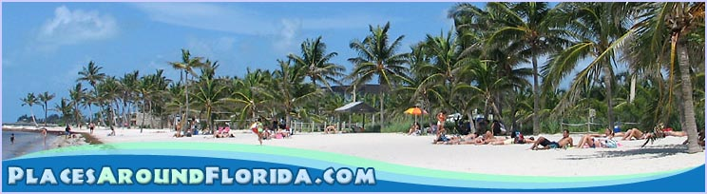
Released on: April 26, 2008, 11:24 am
Press Release Author: Kirby Collins
Industry: Media
Press Release Summary: PlacesAroundFlorida.com has announced new updates to their Central Florida theme park section. Orlando is a city in a constant state of change, there are several new attractions to see with more slated to open later this year.

Press Release Body: Orlando, Florida - PlacesAroundFlorida.com has announced new updates to their Central Florida theme park section. Orlando is a city in a constant state of change, there are several new Orlando Attractions to see with more slated to open later this year. Along with popular theme attractions such as the Disney World Resorts, there are now a whole host of new rides and attractions to get acquainted with. SeaWorld has a new water park; Aquatica, Universal Studios has a new motion simulator ride; the Simpsons and CityWalk has a new karaoke club where you're the star.
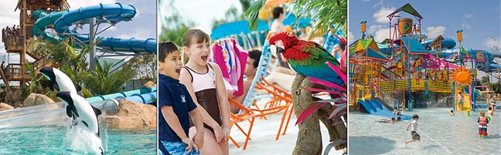
Aquatica is the newest water park to open and is part of SeaWorld, its a unique water park where you can play alongside the sea life. The new park sits on 59 acres in the center of Orlando, this water park offers you the chance to slide down an eight lane racing slide, relax along a lazy river or stretch out on a patch of their white sand beach. At Aquatica Water Park in Orlando you can also get a unique look at their Commerson's Dolphins as you drop through an enclosed water slide that goes right through the lagoon in which they are kept. SeaWorld itself has many animal shows such as 'Believe' featuring Shamu and the rest of their Killer Whale family.
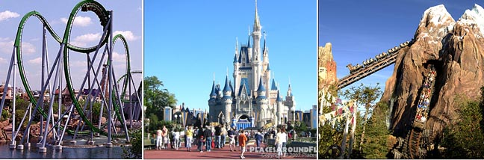
The Simpsons is a new ride opening this spring at Universal Studios. Based on familiar characters from the show, Homer and the family take you on misadventures as they head out to spend the day at the fictional Krustyland amusement park. This motion simulator ride is projected onto an 80 foot dome and gives you the feeling that you are actually in the car with the Simpson family as they go through the town and park.
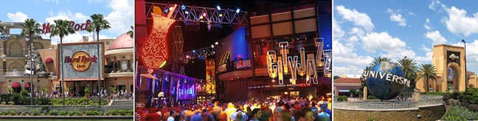
Universal Studios CityWalk recently opened Rising Star, a different kind of karaoke club where you can sing with a live band and back up singers. They also have a top 10 challenge where participants compete for park passes and other prizes.
In addition to the expanded coverage of Central Florida theme parks, PlacesAroundFlorida.com has launched three new photo galleries featuring CityWalk at Universal Studios, Sea World and the Magic Kingdom.
PlacesAroundFlorida.com can help tourist save money by offering in-dept travel information and details on smaller attractions around Central Florida.
About: PlacesAroundFlorida.com is a travel website catering to the Florida tourism market and offers visitors information about Florida Travel. You can visit their website at http://www.placesaroundflorida.com.
Web Site: http://www.placesaroundflorida.com
Contact Details: Kirby Collins
http://kirbycollins.com

