Poetic Guide Provides Timely Gift of Wisdom

Released on: April 18, 2008, 3:53 am
Press Release Author: Portal Press
Industry: Retail
Press Release Summary: A unique new little gift book provides bite-sized wisdom in an original poem with a modern twist to the classic motivational poem, the Desiderata.
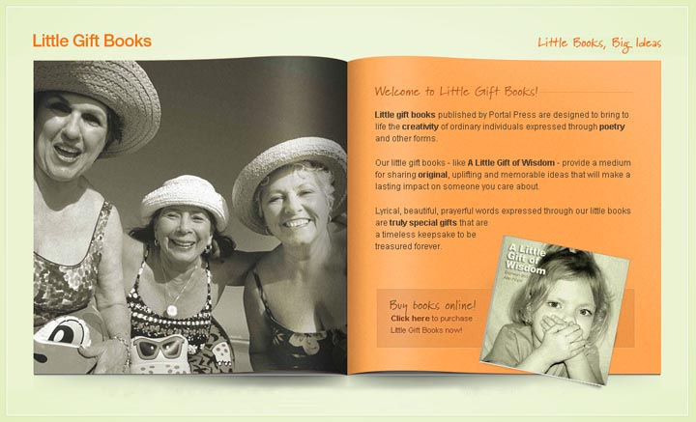
Press Release Body: Some parents complain, others have therapy but one mother-of-two took things to a whole new level when her kids began behaving badly.
When Bronwyn Hope, 44 began to recognise some distressing negative behaviour from her 14-year-old son, she took a unique step to do something positive about it.
She wrote a poem providing an instruction about attitudes she believed were important for her children to develop – and self published it in a little gift book.
The result is “A Little Gift of Wisdom”, a small, CD-sized book in which Bronwyn’s poem is presented alongside a series of compelling images that position the book as a timeless keepsake.
“The poem is a modern version of the Desiderata, a wonderful poem that was penned by Max Ehrmann in 1928 and which comprises a series of instructions to help people cope with life,” Bronwyn says.
“It is my way of responding in a positive and creative way to what I see happening around me. Many people, especially children, are losing their way primarily because they don’t have the kind of guidance they should have. We’ve become such a complex society where social networks are much more fragmented and the teachings that were once passed down through the generations have been lost.
“I hope my little book will go a small way toward providing some of that guidance, even if it’s in just a bite-sized bit,” says Bronwyn.
“There are ways to live that I believe with all my heart are the ways that help you get through life if not unscathed, then at least in one piece. My instructions are about how to live well now and I hope, they will help both children and adults to navigate their paths with courage and confidence.”
A Little Gift of Wisdom is a unique gift book that contains an original verse in open prose format and carries positive messages of compassion, hope and personal empowerment.
The book maybe purchased at www.littlegiftbooks.com for AUD 17.95 including taxes and postage.
Web Site: http://www.littlegiftbooks.com
Contact Details: Bronwyn Hope
80 Broadwater Terrace, REDLAND BAY Q 4165
61-7-3206 9213
bkehope@iprimus.com.au
Cell: 0413 018 457

