Aeris Adds Advanced Metering Infrastructure Content to Website; Discusses Economic and Environmental Benefits


Released on: May 6, 2008, 8:37 am
Press Release Author: Aeris Communications
Industry: Energy
Press Release Summary: Aeris Communications added an article reviewing smart energy solutions to its Website. The article provides an overview of Advanced Metering Infrastructure (AMI), an “intelligent” technology that includes metering systems capable of recording and reporting energy consumption and other measurements at more frequent intervals than the typical billing cycle (usually monthly). The full article is available for viewing at http://www.aeris.net/articles/advanced-metering-infrastructure-ami.html.
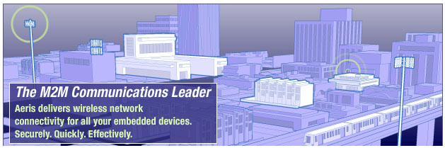
Press Release Body: San Jose, Calif. – May 6, 2008 – Aeris® Communications, the leading wireless communications service provider dedicated exclusively to the Machine-to-Machine (M2M) and telematics marketplace across North America, today announced the company has added an article reviewing smart energy solutions to its Website.
The article provides an overview of Advanced Metering Infrastructure (AMI), an “intelligent” technology that includes metering systems capable of recording and reporting energy consumption and other measurements at more frequent intervals than the typical billing cycle (usually monthly). The full article is available for viewing at http://www.aeris.net/articles/advanced-metering-infrastructure-ami.html.
Readily deployed over wireless networks, advanced metering technology will work with today’s energy sources (gas, water, electricity) and provides answers for management and conservation of future renewable energy grids. Through the use of AMI, development and management of new power markets promises both a brighter and greener future for all involved in the energy equation.
The article provides an overview of current and future uses of AMI and provides details about the benefits of implementing AMI including improved network reliability and system responsiveness as well as increased meter functionality. The article also outlines economic and environmental efficiencies.
About Aeris Communications, Inc.
Aeris® is the leading wireless communications service provider dedicated exclusively to the Machine-to-Machine (M2M) and Telematics marketplace across North America. Aeris has assembled and seamlessly integrated its top tier carrier partner networks through AerFrame™ to provide customers with simplified, unified, reliable, and even customized network services for M2M and Telematics applications. Since 1992, Aeris has developed expertise and patented technologies now proven on millions of devices and billions of messages per year. Aeris provides expert services, superior reliability, broader coverage, lower latency, and unsurpassed customer support and managed services. For more information, please visit http://www.aeris.net or call 1-888-GO-AERIS.
Web Site: http://www.aeris.net
Contact Details: Christina Cassell
PR for Aeris Communications
aeris@bockpr.com
3750 S. Susan Street, Ste. 100
Santa Ana,CA 92704
phone 714 540-1030
fax 714-540-1060

