Drijo is the Ebay of Car Pooling*/Ride Sharing and powered by Google Maps API


Released on: May 21, 2008, 3:20 am
Press Release Author: Walter Demmelhuber
Industry: Internet & Online
Press Release Summary: At www.drijo.com an auction-based website can be found which offers ride-sharing and car-pooling, making partial use of Google Maps(TM) technology
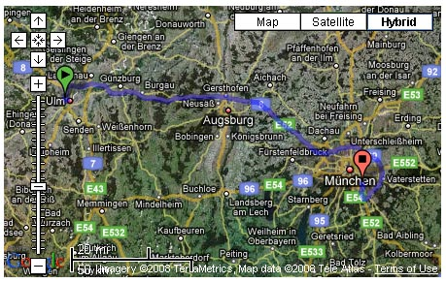
Press Release Body: Mountain View, CA, May 21, 2008
Ride sharing & car pooling is a phenomena similar to a second-hand product market. In both cases a great majority of people are not doing it principally for environmental reasons but to save cost, use High Occupancy Vehicle lanes, etc.
It is first and foremost a social stigma and practicality/matching issue to find the right person to share a ride.
Regarding that dilemma eBay overcame three issues in the product market. To have value attributed to seemingly worthless second-hand stuff ( which would be the empty seats in ride sharing ). To make it socially acceptable to buy second-hand in many industrialized countries. In all cases it is socially accepted to save costs with eBay.
In a visually very attractive way, DriJo offers a simple method to overlay and compare routes of drivers and potential passengers. "Using an auction-based method similar to other popular auction sites should," according to the CEO Walter, "animate more drivers to offer rides, especially on highly demanded routes".
DriJo with its auction-based ride-sharing model assures that:
supply and demand of routes based on the starting and arrival address are overlaid and compared automatically and shown on maps or satellite pictures, based on the Google Maps( TM ) database, practically all addresses, even remote ones in the country-side, can be found - similarly to navigation devices,
the cost of ride sharing between driver and passenger is determined by supply and demand via an auction, a registration of all users gives additional security, feedback after traveling by both driver and passenger increases the trustworthiness of both of them.
"Our matching also allows to compare longer routes with shorter requests," according to the CTO Peter, "and the driver can even define an optional pick-up and drop-off zone along the route to be more attractive to potential passengers."
Paid ride-sharing is popular in both the US and Europe. In the primary countries in Europe and US/Canada it is estimated to be well over 50.000/day.
On a general basis the market of ride sharing agencies is presently badly distributed between many small ad-based institutions. As a consequence it is very difficult to find regional and long-distance trips in one agency. Additionally these companies generate their own databases which in practically all cases do not include addresses or smaller towns.
DriJo is presently owner-financed and focuses via its patented technology and the innovative business model on the redefinition of the ride-sharing market.
* ( trendhunter.com )
Web Site: http://www.drijo.com
Contact Details: Walter Demmelhuber
walter@drijo.com
Mountain View, California
Telephone: +1-650-276-0383

