New Exposé to Shed Light on Seventh day Adventist Church Controversy

Released on: May 5, 2008, 8:41 am
Press Release Author: Mary Champion
Industry: Non Profit
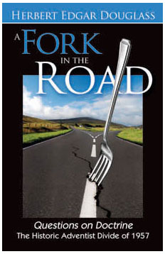
Press Release Summary: Dr. Herbert E. Douglass’ A Fork in the Road, a powerful new exposé that chronicles a significant and controversial chapter in the history of the Seventh-day Adventist Church.
Press Release Body: News Release 5/05/08
Contact: Mary Champion
Phone: 517.279.1304
New Exposé to Shed Light on Seventh-day Adventist Church Controversy
COLDWATER, MICH. Dwight Hall, president of Remnant Publications, a non-profit Christian publisher, announces the release of Dr. Herbert E. Douglass’ A Fork in the Road, a powerful new exposé that chronicles a significant and controversial chapter in the history of the Seventh-day Adventist Church.
A key eye-witness to the drama surrounding the publication of Seventh-day Adventists Answer Questions on Doctrine in 1957, Dr. Douglass shares his personal experience, and often provocative insights, with the backlash of the book and its continuing repercussions on church theology today.
Says Dwight Hall, “Let there be no mistake: this isn’t just a passive documentation of the events that followed Questions on Doctrine; it offers an important historical context from an insider’s own experience in the crisis. It’s a riveting read that asks and answers a lot of questions today’s Adventist believers and thinkers are sure to have.”
Asked why he chose to tackle the topic after 50 years, Dr. Douglass responded, “Most, if not all, of the so-called ‘dissident’ groups of the last 45 years are direct results of the positions espoused by Questions on Doctrine on the atonement and the incarnation. Our church needs insight now into this complex history as it seeks not only healing but also growth in the years to come.”
Both informative and riveting, A Fork in the Road also shares evidence brought to light by Julius Nam and George Knight, who show the depth of criticism by those who were alarmed by the book’s reformulation of Adventist theology—even as private letters and other evidences show how an important defender of Adventist theology was left to stand alone in the outcry.
During his distinguished career, Dr. Herbert Douglass has served as a pastor, ministry president, college professor, and administrator. He is also the author of more than 13 books and numerous articles focusing on Christ, the great controversy, and the church.
For more information about A Fork in the Road, and to order copies, contact Remnant Publications at 517-279-1304. You may also visit www.RemnantPublications.com Or write to Remnant Publications • 649 E. Chicago Road • Coldwater, MI 49036.
Web Site: http://www.remnantpublications.com
Contact Details: Mary Champion
Remnant Publications • 649 E. Chicago Road • Coldwater, MI 49036.
517-279-1304

